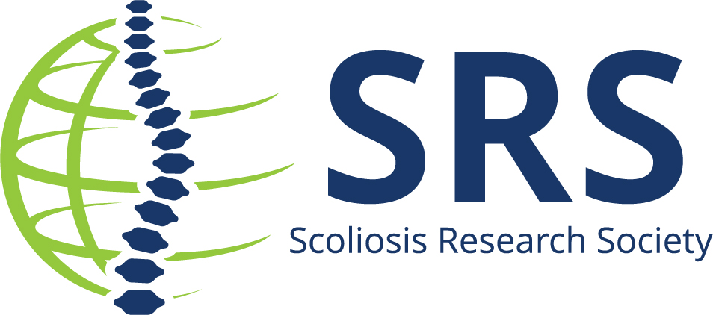

Hospital/University/Organization Announces (Insert Name and Title) is the Winner of the Biedermann Innovation Award

During the 58th Annual Meeting in Seattle, Washington USA, the Scoliosis Research Society (SRS) announced this year’s recipient of the Lutz Biedermann award recognizing innovation in the field of spinal deformity.

Hospital/University/Organization is pleased to announce the (insert year) Biedermann Innovation Award Winner:

(Insert name of awardee and title of the research) was awarded $49,454 to support research.

“Insert quote about winning and/or a quote from your organization.”

The Biedermann Innovation Award is designed to support innovative research by a young clinical investigator in the field of spinal deformity.

The award is available to SRS members age 45 or younger at the time of the award. Award winners will have demonstrated clinical or translational research promise and submit a research proposal designed to enhance innovation in spinal deformity treatment. All applications are reviewed and selected by the SRS Research Grant Committee.

For more information on SRS Grant opportunities, visit our website. To contribute to grant research funding, review all the ways you can donate to SRS.

About Scoliosis Research Society
The Scoliosis Research Society is a non-profit, professional organization, made up of physicians and allied health personnel. Our primary focus is on providing continuing medical education for health care professionals and on funding/supporting research in spinal deformities. Founded in 1966, SRS has gained recognition as the world's premier spine deformity society. Please visit www.srs.org for further information. Also follow us on Twitter, Facebook, LinkedIn and Instagram.
###

