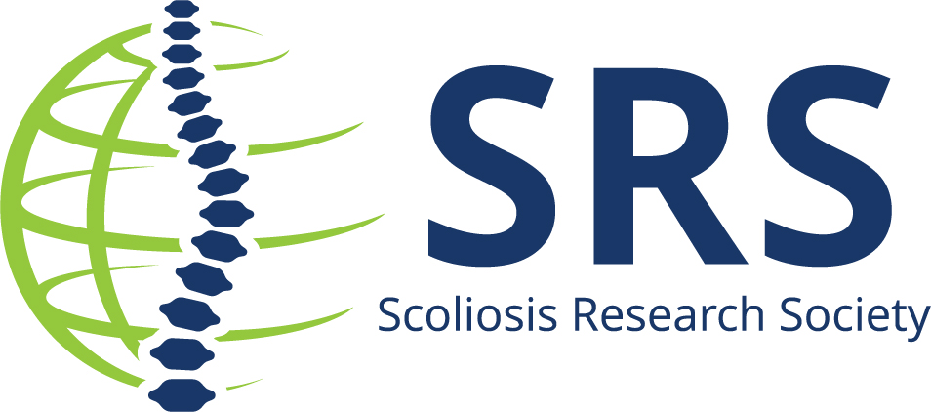

Contact: Michele Sewart, PMP | Scoliosis Research Society
msewart@srs.org |414-231-8158

Hospital/University/Organization is Pleased to Announce Employee/Professor/Doctor is Recipient of Jointly Funded Research Grant

XXXX – In 2018, the Scoliosis Research Society and Fondation Yves Cotrel – Institut de France announced their partnership to jointly fund basic science research with a focus on pediatric scoliosis. This award supports projects that will be performing work in pediatric scoliosis. Projects investigating molecular and cellular mechanisms, medical imaging as well as characterizing biomechanical aspects underlying the disease are eligible. Basic science research using human populations or animal models are highly encouraged.
Both the SRS Research Grant Committee and a group of representatives from the Fondation Yves Cotrel – Institut de France review all full submissions to the SRS-Cotrel Foundation Basic Science Research Grant.

Nancy Miller, MD is the awardee of this year’s grant, totaling almost $50,000 for her topic: Expanding our Understanding of Human KIF7 Mutations Associated with AIS and Responsiveness to Estrogen
Insert quote from institution
Winners of the SRS-Cotrel Foundation Basic Science Research Grant are required to provide progress reports for review and share their findings at the Cotrel Foundation Annual Meeting in the final year of the grant award.

About Scoliosis Research Society
The Scoliosis Research Society is a non-profit, professional organization, made up of physicians and allied health personnel. Our primary focus is on providing continuing medical education for health care professionals and on funding/supporting research in spinal deformities. Founded in 1966, SRS has gained recognition as the world's premier spine deformity society. Please visit www.srs.org for further information. Also follow us on Twitter, Facebook, LinkedIn and Instagram.
About Fondation Cotrel – Institut de France

Created by the will of Dr. Yves Cotrel in 1999, the Fondation Cotrel – Institut de France is a non-profit foundation. Since its creation, the Cotrel Foundation has supported over 65 research projects worldwide, gathering teams of various disciplines, focusing on etiology of idiopathic scoliosis. It also aims to raise awareness on early detection. Please visit www.fondationcotrel.org for further information.

