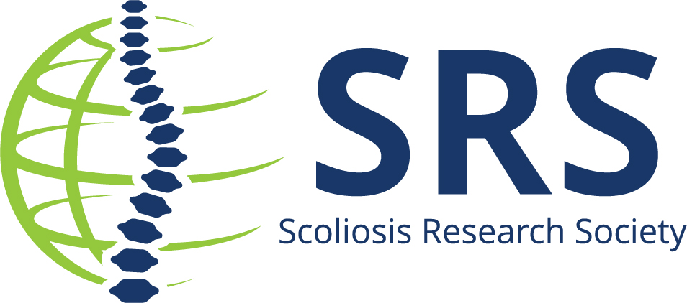

Hospital/University/Organization is Pleased to Announce Insert Name is the New President/Board Member of the Scoliosis Research Society

. Each year, the society advances a Board of Directors who are dedicated to furthering innovation and education in line with the Society’s mission.

On Saturday, September 9, at the society’s 58th Annual Meeting in Seattle, Washington USA, XXXX, accepted the role as XXX.

Insert quote

XX steps into a leadership role on a board filled with prestigious members, spanning the globe from Europe, Asia and Canada. The SRS is pleased to present the 2023-2024 Board of Directors:

- Marinus de Kleuver, MD, PhD, President
- Laurel C. Blakemore, MD, President Elect
- Suken A. Shah, MD, Vice President
- Serena S. Hu, MD, President I
- Christopher I. Shaffrey, MD, Past President II
- David Skaggs, MD, MMM, Treasurer
- Ferran Pellise, MD, PhD, Secretary, Governance Council Chair
- Parveen V. Mummaneni, MD Secretary Elect
- Ron El-Hawary, MD, Communication Council Chair
- Munish C. Gupta, MD, Education Council Chair
- Douglas C. Burton, MD, Research Council Chair
- Justin S. Smith, MD, PhD, Research Council Chair Elect
- Lindsay Andras, MD, Director at Large
- Firoz Miyanji, MD, FRCSC, Director at Large
- Kota Watanabe, MD, PhD, Director at Large
- Eric O. Klineberg, MD, Director at Large
- Micheal G. Vitale, MD, MPH, Director at Large
- Michelle C. Welborn, MD, Director at Large

About Scoliosis Research Society
The Scoliosis Research Society is a non-profit, professional organization, made up of physicians and allied health personnel. Our primary focus is on providing continuing medical education for health care professionals and on funding/supporting research in spinal deformities. Founded in 1966, SRS has gained recognition as the world's premier spine deformity society. Please visit www.srs.org for further information. Also follow us on Twitter, Facebook, LinkedIn and Instagram.

###

