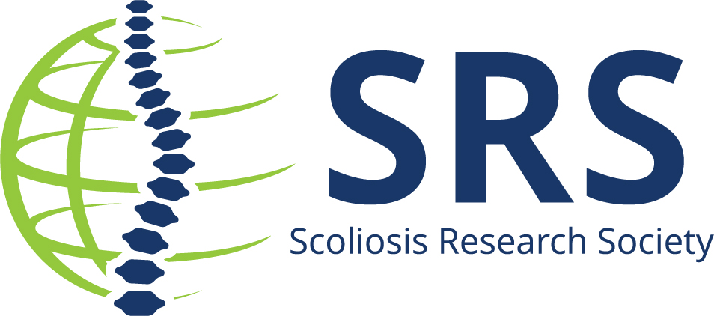
Contact: Name/Email/Phone for follow up

(Insert name) to Present at the Prestigious International Meeting on Spine Techniques in San Diego

(insert city, state) – (insert name of institution) is pleased to announce that (insert name) is one of the presenters at the International Meeting on Spine Techniques
The 31st International Meeting on Advanced Spine Techniques (IMAST) – powered by the Scoliosis Research Society – is a top-tier meeting experience, in San Diego, CA, where leading spine surgeons, innovative researchers, and the most advanced spine technologies come together in an international forum to demonstrate and discuss recent advances in spine surgery.
Dr./Professor/ (Insert name) is presenting on the (insert topic) on date/ day/time.
(insert quote or more details on topic)
For more information review the preliminary program.
The 2024 International Meeting on Advanced Spine Techniques is considered the top event for innovation in the spine health field. Presenting among the international audience of spine professionals is a great honor.
About Scoliosis Research Society
The Scoliosis Research Society is a non-profit, professional organization, made up of physicians and allied health personnel. Our primary focus is on providing continuing medical education for health care professionals and on funding/supporting research in spinal deformities. Founded in 1966, SRS has gained recognition as the world's premier spine deformity society. Please visit www.srs.org for further information. Also follow us on Twitter, Facebook, LinkedIn and Instagram.
###

