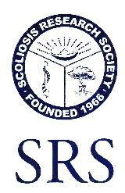
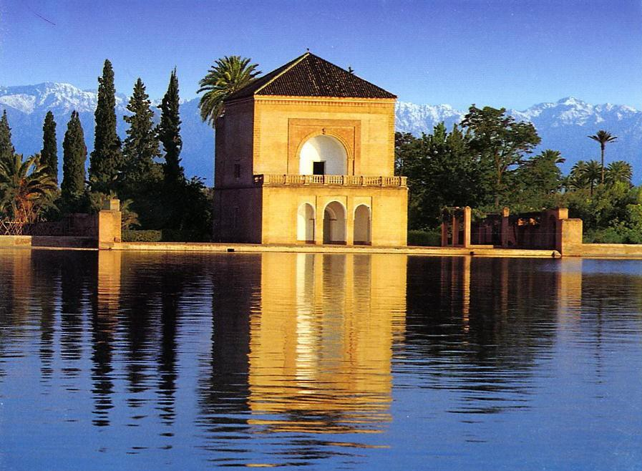
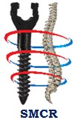
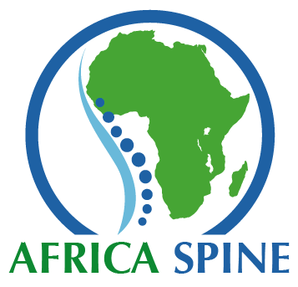

SCOLIOSIS RESEARCH SOCIETY

1ST Regional WWC Course
& MOROCCAN SPINE SOCIETY 6TH Congress
Marrakech, Morocco 3-5 December, 2015

SRS : Basic and advanced Concepts
in Spinal Deformity

SMCR: Spine Trauma, Degenerative and Miscellaneous

Organised by : S M C R & S R S
With the support of AfricaSpine, P.A.S.S. MaghrebSpine & SMACOT
VENUE: PALM PLAZZA HOTEL, MARRAKECH

OFFICIAL ORGANISING AGENCY: SIGMACO BUSINESS TRAVEL
Phone Miss Nadia Amir : + 212 522 20 90 92 / 96 Email: sigmacobusinesstravel@gmail.com www.sbt.co.ma
LOCAL CHAIRMEN : chliyah.m@gmail.com + t.benzakour@gmail.com + tarikfikry@gmail.com
Accreditation/
On Request Accreditation for Continuing Medical Education
Course Co-Chairmen/
- Kamal Ibrahim
- Mark Weidenbaum
- Hani Mhaidli
- Thami Benzakour
- M'hamed Chliyah
- Tarik Fikry

SRS /SMCR 2015
Faculty
- Youssry El Hawary Egypt
- Richard Assaker France
- Daniel Chopin France
- Fred Otsyeno Kenya
- Rachid Haidar Lebanon
- Khalil Kharrat Lebanon
- Thami Benzakour Morocco
- M'hamed Chliyah Morocco
- Tarik Fikry Morocco
- Bouchaib Redouane Morocco
- Alaa Ahmad, Palestine
- Mkhululi Lukhele South Africa
- Jesús Burgos Spain
- Enrique Izquierdo Spain
- Hani Mhaidli Spain
- Ferran Pellisé Spain
- F. Sánchez Pérez-Grueso Spain
- Ahmet Alanay Turkey
- Alpaslan Senkoylu Turkey
- Hossein Mehdian UK
- Ali Baaj USA
- Kamal N. Ibrahim USA
- Baron Lonner USA
- Anis Mekhail USA
- Mokbel Chedid USA
- Ibrahim Omeis USA
- Ken Paonessa USA
- Mark Weidenbaum USA

- FRIDAY DEC. 4th : STARTING AT 14:20 , SRS WWC- GOP PROGRAM
08:00 | Registration Open
14:20-14:30 | - Introductory Remarks – Goals of Course  Kamal Ibrahim/Tarik Fikry
Session I: Adolescent Spinal Deformities
Moderators : Thami Benzakour / Hani Mhaidli
14:30-14:40 | Natural history, decision making: adolescent spinal deformity  Khalil Kharrat
14:40-14:50  14:50-15:00  15:00-15:10 | Radiographic evaluation of spinal deformity  Bouchaib Redouane  Non-operative treatment of adolescent idiopathic scoliosis (AIS).  Ken Paonessa  Principles of surgical correction for AIS  Kamal N. Ibrahim
15:10-15:20 | Discussion
15:20-15:50 | Case Presentation Panel 1 – AIS  2 CASE PRESENTATIONS

Session II: Early Onset Scoliosis (EOS) / Congenital
Moderators : M'hamed Chliyah /Youssry El Hawary
hliyahLIYAH Youssry El Hawary
15:50-16:00 | Natural history, diagnosis and investigations of EOS  Alaa Ahmad
16:00-16:10  16:10-16:20  16:20-16:30 | Management of EOS  F. Sánchez Pérez-Grueso  Congenital Scoliosis: classification, natural history and management  Fred Otsyeno  Pre-operative traction views in surgical scoliosis correction Mkhululi Lukhele
16:30-16:40 | Discussion
16:40-17:00 | Case Presentation Panel 2 – EOS / Congenital  2 CASES PRESENTATIONS

17:00-17:30 | Coffee Break
Session III: Sagittal Alignment of the Spine During Growth
Moderators : Kamal N. Ibrahim / Rachid Haidar
17:30-17:40 | Sagittal alignment of the spine and pelvis in the pediatric population  Jesús Burgos
17:40-17:50 | Diagnosis and Treatment of Scheuermann Kyphosis
17:50-18:00 | Hossein Mehdian  Spondylolysis and spondylolisthesis management and treatment  Baron Lonner
18:00-18:10 | Adolescent spinal deformity: clinical outcomes and surgical complications Ahmet Alanay
18:10-18:20  18:20-18:40 | Discussion  Case Presentation Panel 3  2 CASE PRESENTATIONS  Adjourn

- SATURDAY DEC. 5th : STARTING AT 8:30, SRS WWC- GOP PROGRAM
Session IV: Neuromuscular Spinal Deformity
Moderators : Baron Lonner / Khalil Kharrat
08:30-08:40 | Neuromuscular spinal deformity: types, natural history  F. Sánchez Pérez-Grueso
08:40-08:50 | Non-operative treatment of neuromuscular spinal deformity  Alpaslan Senkoylu
08:50-09:00 | Surgical management of neuromuscular spinal deformity  Hossein Mehdian
09:00-09:10 | Back pain in children: investigation and treatment
09:10-09:20  09:20-09:40 | Ferran Pellisé  Discussion  Case Presentation Panel 4  2 CASE PRESENTATIONS

Session V: Adult Spinal Deformities
Moderators : Ferran Pellisé /Alpaslan Senkoylu
09:40-09:50 | Sagittal balance in adult spinal deformity  Daniel Chopin
09:50-10:00  10:00-10:10  10:10-10:20 | Adult scoliosis: management and treatment  Baron Lonner  Spine surgery for osteoporotic and elderly patients  Youssry El Hawary  Complications of adult deformity surgery  Hani Mhaidli
10:20-10:30 | Discussion
10:30-10:50 | Case Presentation Panel 5 – ADULT  2 CASE PRESENTATIONS

10:50-11:10 | Coffee Break

Session VI Preparation for Spine Surgery
Moderators : Richard Assaker / Mokbel Chedid
11:10-11:20 | Measuring quality and value in spine surgery SRS 22  Rachid Haidar
11:20-11:30  11:30-11:40  11:40-11:50 | Infection Prevention and Control  Mark Weidenbaum  Management of blood loss during surgery  Ibrahim Omeis  Intraoperative neuro- monitoring  Ali Baaj  Ali Baaj
10:20-10:30 | Ali Baaj  Discussion
11:50-12:00  12:00-12:10 | Patient positioning for spinal surgery: recommendations to avoid complications  Ken Paonessa  Discussion

Session VII Lumbar Spinal Stenosis and Deformity
Moderators : Mark Weidenbaum/ Daniel Chopin

12:10-12:20 | Pathophysiology and conservative treatment of lumbar stenosis  Ahmet Alanay  10:20-10:30  Ali Baaj  Discussion
12:20-12:30  12:30-12:40  12:40-12:50 | Stenosis and degenerative spondylolisthesis  Anis Mekhail  Spinal stenosis with degenerative scoliosis  M’hamed Chliyah  Minimally invasive techniques for degenerative spine disease  Spinal Stenosis with Degenerative Scoliosis  Minimally Invasive Decompression Techniques
10:20-10:30 | Richard Assaker  Discussion
12:50-13:00 | Discussion

Session VIII Miscellanea
Moderators : Ahmet Alanay/Hossein Mehdian
13:00-13:10 | Osteoporotic vertebral compression fractures:  vertebroplasty versus kyphoplasty  Hani Mhaidli
13:10-13:20  13:20-13:30 | Surgical treatment for thoracolumbar burst fracture  Thami Benzakour  Management of spinal infections  Mokbel Chedid  Spine Surgery for Osteoporotic and Elderly Patients
13:30-13:40  10:20-10:30 | Guidelines for the management of metastatic spinal disease  Ken Paonessa  Discussion
13:40-13:50  13:50 | Discussion  Adjourn  M'hamed Chliyah /Thami Benzakour /Hani Mhaidli

14:00-15:30 LUNCH
15:30-18:00 WORKSHOPS

General Information /

Venue /
PALM PLAZZA HOTEL, MARRAKECH

OFFICIAL ORGANISING AGENCY:

SIGMACO BUSINESS TRAVEL
Phone Miss Nadia Amir : + 212 522 20 90 92 / 96
Email: sigmacobusinesstravel@gmail.com www.sbt.co.ma
LOCAL HOSTS : chliyah.m@gmail.com
t.benzakour@gmail.com
tarikfikry@gmail.com

MEETING REGISTRATIONS:
EARLY BEFORE OCTOBER 1st : African Seniors, €:150 / African Residents 90
    - Non African Seniors, €:300 / Non African Residents 250
BETWEEN OCT.1st and NOV. 20th African Sen. € 180 / African Residents 120
    - Non African Seniors, €:350 / Non African Residents 300
AFTER NOVEMBER 20th: African Seniors, €:200 / African Residents 140
    - Non African Seniors, €:380 / Non African Residents 330
HOTEL ACCOMODATION:

EARLY: Single room : : € 80 / Double room : € 90
AFTER OCTOBER 1st Single room : : € 90 / Double room : € 100
Sightseeing and attractions:

Marrakech offers superb sightseeing in the city with spectacular sites and palaces, its great and mysterious
places, and out of the town in the regions of the Atlas Mountains that feature impressive landscapes

Course Secretariat /

Phone: + 212 522 20 90 92 / 96

Fax:
Email sigmacobusinesstravel@gmail.com www.sbt.co.ma

Official Languages /
English,

