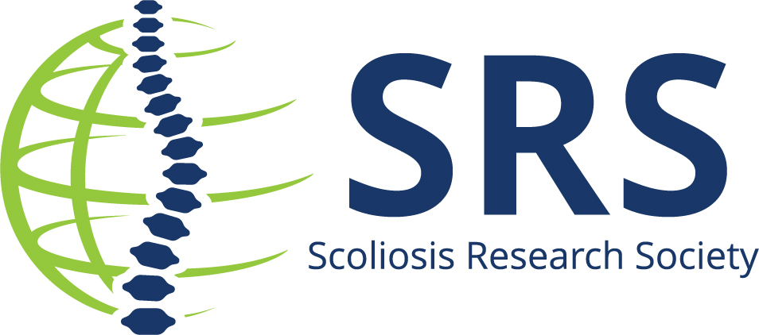

Contact: Michele Sewart, PMP | Scoliosis Research Society
msewart@srs.org |414-231-8158

Name of Institution/Hospital is Pleased to Announces Insert Name is the Winner of the Prestigious Russell A. Hibbs or John H. Moe or Louis A. Goldstein Awards
During the 61st Annual Meeting in Sydney, Australia, the Scoliosis Research Society (SRS) announced the winners of the Russell A. Hibbs, John H. Moe & Louis A. Goldstein Awards. Named after pioneers in scoliosis surgery, the awards are given to the best basic research and best clinical research papers.

Choose the winning paper information:

Hibbs Best Clinical:
Hibbs Best Basic Science:
John H. Moe Best Basic Science E-Point:
Luis A. Goldstein Best Clinical Research E-Point:

Nominees for the awards are selected by the Program Committee from the submitted abstracts for SRS Annual Meeting. The nominees are invited to submit their paper’s manuscript which is reviewed by the Program Committee. During the meeting, attendees vote for their favorite presentation via the SRS Annual Meeting app and the popular votes and manuscript scores are taken into consideration by the Program Committee, who select the final winners.

Insert quote

About Scoliosis Research Society
The Scoliosis Research Society is a non-profit, professional organization, made up of physicians and allied health personnel. Our primary focus is on providing continuing medical education for health care professionals and on funding/supporting research in spinal deformities. Founded in 1966, SRS has gained recognition as the world's premier spine deformity society. Please visit www.srs.org for further information. Also follow us on X, Facebook, LinkedIn and Instagram.
###

