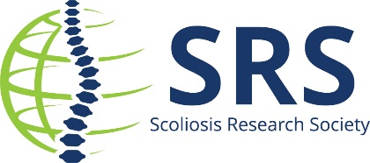
Contact: Name/Email/Phone for follow up

(Insert name) to Present at the Scoliosis Research Society’s Annual Meeting
in North Carolina, USA

(insert city, state) – (insert name of institution) is pleased to announce that (insert name) is one of the presenters at the SRS 60th Annual Meeting.
The Scoliosis Research Society (SRS) Annual Meeting is a forum for the realization of the Society's mission and goals, the improvement of patient care for those with spinal deformities. A Faculty-led Pre-Meeting Course and abstract papers will be presented on an array of topics, including adolescent idiopathic scoliosis, growing spine, kyphosis, adult deformity, minimally invasive surgery, machine learning, and mental health considerations.
Approximately 1,500 attendees take part in the 4-day program which includes a Pre-Meeting Course, Scientific Program, Lunchtime Symposia, Industry Workshops, and E-Point presentations – all covering the latest and greatest scientific research, methods, and techniques in spinal deformity.
Dr./Professor/ (Insert name) is presenting on the (insert topic) on date/ day/time.
(insert quote or more details on topic)
For more information review the preliminary program.
The 2025 Annual Meeting is considered the top event for innovation in the spine health field. Presenting among the international audience of spine professionals is a great honor.
About Scoliosis Research Society
The Scoliosis Research Society is a non-profit, professional organization, made up of physicians and allied health personnel. Our primary focus is on providing continuing medical education for health care professionals and on funding/supporting research in spinal deformities. Founded in 1966, SRS has gained recognition as the world's premier spine deformity society. Please visit www.srs.org for further information. Also follow us on X, Facebook, LinkedIn, TikTok and Instagram.

