Clinical Outcome of Intraoperative Lumbar Nerve Root Monitoring Changes Using Motor Evoked Potentials: A Single Institution Experience
Earl D. Thuet, Lee Tan, MD, Anil Mendiratta, MD, Paul Kent, MD, PhD, Hyunmi Choi, MD, Ronald Lehman, MD, Yongjung Kim, MD, Mark Weidenbaum, MD, Charla Fischer, MD, Lawrence Lenke, MD

NewYork-Presbyterian The Allen Hospital / The Spine Hospital
Columbia University College of Physicians and Surgeons
5141 Broadway
New York, NY 10034

Primary Author Earl D. Thuet
The Allen Hospital/ The Spine Hospital
Neurophysiology Department
5141 Broadway
3 Field West Room 033
New York, NY 10034
Edt9024@nyp.org
Office: 212-932-4342
Fax: 212-932-4341

Clinical Outcome of Intraoperative Lumbar Nerve Root Monitoring Changes Using Motor Evoked Potentials: A Single Institution Experience

Abstract

Study Design: Retrospective

Objectives: To evaluate the effectiveness of using motor evoked potentials to monitoring lumbar nerve root function during spinal surgery.

Background: Intraoperative neurophysiological monitoring (IONM) plays an important role during modern spinal surgery. Somatosensory evoked potentials (SSEPs) and motor evoked potentials (MEPs) can reliably detect intraoperative spinal cord dysfunction. However, the reliability of nerve root monitoring remains an area of controversy. Several factors contribute to the difficulty of monitoring lumbar nerve root function. Overlapping of radicular innervation, the small percentage of motor units that contribute to any MEP stimulation, the variability of the MEP response morphology and the effects of anesthesia must be considered. Despite these limitations, motor evoked potential monitoring can offer valuable information that is not provided by SSEP and EMG monitoring alone. We report the clinical outcome of patients in whom intraoperative nerve root monitoring changes were observed utilizing our MEP warning criteria, with a review of pertinent literature.

Methods: We reviewed all cases of patients undergoing thoracolumbar spinal surgery utilizing multimodality monitoring over a 12-month period. All patients with intraoperative nerve root monitoring changes were identified. Patient demographics, indexed procedure, intraoperative monitoring data, intraoperative investigation and findings, and post-operative neurological status were reviewed.

Results: A total of 337 consecutive patients underwent thoracolumbar spinal surgery over the study period at our institution. No patients were excluded from analysis. Fourteen patients (4.15%) had intraoperative MEP nerve root monitoring changes that met our institution’s warning criteria. In twelve of these 14 patients, (85.7%) the source of nerve root compression was identified by the operating surgeon and intraoperative interventions were performed. The remaining two patients (14.3%) had nerve root monitoring changes that did not correspond to any obvious source of nerve root compression at the corresponding level, and no intraoperatively and no post-operative neurological deficit were seen in these patients. 8 of the 14 patients (57.1%) with MEP changes were found to have neurological deficits post-operatively, but 7 of these patients made complete recovery; only one patient (7.1%) demonstrated a persistent neurological deficit at the final follow-up visit.

Conclusion: Despite the challenges of lumbar nerve root monitoring, the large majority of intraoperative root-specific monitoring changes were found to correlate with identifiable sources of lumbar nerve root compression. The detected monitoring changes allowed the spine surgeons to perform corrective measures to reduce the risk of permanent neurologic deficits. Based upon our experience, MEP nerve root monitoring is a valuable tool for intraoperative identification of nerve root compression, and utilization of this modality may improve surgical outcome.

Key Points: Intraoperative neurophysiological monitoring, IONM, Nerve root monitoring, SSEP, MEP, EMG, Spine surgery, Deformity correction, complication, neurological deficit

Level of Evidence: Level II

Introduction

Multimodal intraoperative neurophysiological monitoring (IONM) has become standard practice for most spinal deformity and spinal tumor cases; and many spine surgeons also utilize IONM for routine (degenerative) spinal surgeries. The most common modalities include somatosensory evoked potentials (SSEP), transcranial electrical motor evoked potential (TCeMEP or MEP), spontaneous/ triggered electromyography (sEMG/ tEMG), and much less frequently descending neurogenic-evoked potentials (DNEP). The efficacy of multimodal IONM for spinal cord function has been reported by various authors with both high sensitivity and specificity. In contrast, the efficacy of IONM for nerve root monitoring remains an area of controversy. The advent of TCeMEP monitoring was a major advance that allowed for real-time assessment of the central nervous motor pathway. TCeMEP has become the standard for monitoring of the spinal cord motor tracts during spinal surgery, but this modality has not been routinely adopted for the monitoring of lumbar nerve root function. Rather, monitoring of spontaneous EMG activity has been relied upon for the assessment of root integrity. Spontaneous EMG monitoring however, is sub-optimal, given the high false positive and false negative rates associated with the technique. Efforts to monitor lumbar nerve root function and predict outcome utilizing MEP testing have yielded inconsistent results. Several factors have been cited as contributing to the difficulty of monitoring lumbar root function. Overlapping and variable root innervation, limited data sampling due to the relatively small percentage of motor units activated by each MEP stimulation, the inter-stimulation variability of the MEP response morphology, and the effects of varying anesthesia techniques all combine to confound identification of significant change. Importantly, the monitoring community lacks a standardized set of warning criteria for MEP testing.
Despite these potential limitations, we believe that clinically valuable information can be obtained with the available technique. In our institution, we routinely utilize MEPs for nerve root assessment in all monitored surgical procedures involving the lumbar spine. In this paper, we describe our single-institution monitoring techniques, including warning criteria, and the clinical outcomes of surgical patients with intraoperative monitoring changes along with a review of the pertinent literature.

Methods

We identified all patients who underwent thoracolumbar spinal surgery from August 13th, 2015 to August 12th, 2016 at our University Medical Center. Multimodal IONM (SSEP, MEP, sEMG) techniques were performed to monitor lumbar nerve roots in all patients. Medical records were reviewed and patients with intraoperative MEP nerve root monitoring changes were identified. Patient demographics, intraoperative monitoring data, intraoperative finding and intervention, as well as post-operative neurological exam findings were reviewed.

For all patients, the anesthetic protocol consisted of total intravenous anesthesia (TIVA) using infusions of propofol at 60mcg/kg/min and remifentanil .1 to .3mcg/kg/hr or sufentanil .1 to .3mcg/kg/hr. Infusions of short-acting muscle relaxants (rocuronium, etc.) were titrated to achieve on average two or three out of four twitches on a train of four (TOF). Bilateral soft gauze roll bite-blocks were placed over the molars bilaterally with the tongue safely centered prior to any stimulation. The infusion of neuromuscular blockade to achieve partial paralysis was used to minimize patient movement during MEP stimulation and reduce the risk of bite injuries. Partial relaxation also optimized the recording to SSEP responses.
Multimodal IONM was performed by an experienced neuromonitoring team, each consisting of a CNIM certified technician with at least three years of full time monitoring experience, along with a neurologist with expertise in IONM. Our standard monitoring protocol included SSEPs, MEPs, sEMG, which were performed in every surgical procedure. Triggered EMG for pedicle screw testing was used to test the optimal placement of pedicle screws at the discretion of the surgeon.
Transcranial MEPs were stimulated using two 13mm straight non-insulated needle electrodes (Rhythmlink, Columbia, SC) placed subcutaneously over the motor cortex at C3 and C4 (International 10-20 System). Stimulation intensity was incrementally increased to a maximum intensity of 500 volts until a compound muscle action potential (CMAP) was obtained from each muscle recording site. Stimulation frequency ranged from 350 to 950Hz. Train count was most often 5 stimuli, with a priming stimulation of 2-3 stimuli. Each stimulation variable was adjusted prior to incision in order to obtain the strongest responses at the lowest stimulation threshold. Recording sites were selected to represent effector muscle information from each lumbar level. We sought to obtain information from the surgical levels potentially at risk for injury, as well as from adjacent levels that could also provide “control” data in case of monitoring changes. Bilateral upper extremity muscles, abductor pollicis brevis and adductor digiti minimi of the hands, were also monitored in every procedure. These served both as a “control” for lower extremity changes and were also used to monitor for positional changes in responses due to prone positioning. A list of spinal levels and the effector muscles used are included in Figure 1.
Lower extremity MEP responses were recorded bilaterally from the iliopsoas major, vastus medialis, anterior tibialis, the extensor hallucis longus, medial gastrocnemius muscles and abductor hallucis of the foot using paired subdermal needle electrodes (Rhythmlink, Columbia, SC). Bipolar recording, or the use of paired EMG electrodes in each recorded muscle, is critical for response accuracy when attempting to monitor nerve root function. Referential recording, in which the individual electrodes of the pair are placed in separate muscles, should be avoided as a recording technique for nerve root monitoring due to the lack of root specificity. The goal of the technique is the identification of a significant change in a single muscle.
Baseline SSEP and MEP responses were obtained prior to skin incision after the patient was confirmed to have at least 1 to 2 twitches per TOF. The voltage required to reproducibly elicit a compound muscle action potential (CMAP) from all recordable muscle groups was recorded as the baseline threshold. Following the completion of surgical exposure, routine monitoring consisted of the technician alternating between SSEP and MEP testing while also continuously observing spontaneous EMG traces. SSEP monitoring of bilateral posterior tibial (PTN) and ulnar nerves were performed for all procedures; SSEPs from the PTN were recorded nearly continuously throughout the operative procedures.
Intraoperative MEPs were performed at approximately 5 to 10 minute intervals throughout the procedure or at the discretion of the attending surgeon. Following any observed monitoring response changes, MEPs were assessed more frequently, in close coordination with the operating surgeon.
The quality of the baseline MEP responses are an important indicator of the ability to monitor lumbar nerve root function with motor evoked potentials. Responses must be of acceptable amplitude and complexity, and reproducible at a stimulus level that allows for a further 100 volt increase from baseline threshold in the event of a response change. Acceptable complexity is a somewhat subjective descriptor, consisting preferably of multiple polyphasic waves Figure 2. Examples of well-formed, moderately formed and poorly-formed responses are displayed in Figure 3. High amplitude, complex MEP responses that are attainable at thresholds lower than 350 volts were considered optimal. Responses which are reasonably complex, but lower in amplitude and attainable at stimulus intensity less than 400 volts are acceptable, but may be less sensitive to changes in nerve root function Figure 4. Baseline MEP responses that require high levels of stimulation to obtain, such as 425 volts or greater, or have low amplitude with simple, monophasic morphology would be considered unreliable for nerve root monitoring Figure 5. When baseline MEP responses are poorly formed or absent from any of the effector muscles of the surgical levels, the surgeon should be informed that lumbar root sensitivity is sub optimal, or may not be possible for the surgical procedure.

Evaluation of the MEP response is both qualitative and quantitative. Visual interpretation of a 50% or 75% decrease in amplitude allows for rapid identification of a change and a timely alert to the operative surgeon. In the event of any monitoring response change, all non-surgical causes should be immediately excluded by the monitoring team. A train of four (TOF) should be obtained, and no further muscle relaxant should be administered. A decrease of 50 percent in MEP amplitude in at least one of the monitored muscle groups should be considered the first potential indicator of nerve root dysfunction. In order to exclude normal variability as the cause, and to minimize false positive alerts, attempts should be made to recover the response in question. The stimulation intensity should be increased (to a maximum of 100 volts above baseline threshold) to assess for improvement in the MEP responses. Stimulation frequency or interstimulus interval (ISI) should also be adjusted to attempt to recover response amplitude. If the MEP waveform or waveforms in question respond to recovery efforts by increasing in amplitude, and maintain that recovered increase, the surgeon should not be informed, as the changes should be interpreted as normal variability. Warning criteria for our protocol is defined as a loss of amplitude of 75% or greater that remains decreased despite the recovery efforts described above. Notably, simultaneous or subsequent changes to the corresponding lower extremity SSEP or EMG responses lend further support to the possibility of nerve root dysfunction. At the surgeon’s discretion, intraoperative investigations should then be performed to identify potential causes for nerve root injury.

Results
337 consecutive patients underwent thoracolumbar spinal surgery over the study period. A total of 14 patients (4%) had MEP nerve root monitoring changes that met warning criteria. In 12 of the 14 (86%) patients, following the monitoring alert, the surgeon was able to identify or had strong suspicion of nerve root compression at the corresponding spinal levels. As depicted in Table 1, in the majority of case, multiple muscle responses reached warning criteria due to a single event. In these 14 cases, tibialis anterior was affected often (10 patients/ 71%), followed by extensor hallucis longus (8 patients/ 57%), medial gastrocnemius (7 patients/ 50%), vastus medialis (5 patients/ 29%), abductor hallucis brevis (5 patients/ 29%), iliopsoas (1 patient/ 7.1%). In the 12 cases in which increased nerve root compression was identified or suspected, intraoperative decompression resulted in at least partial improvement of MEP responses in (11 of 12/ 92%) patients; these patients had either no post-operative deficit or had transient deficits that completely recovered at follow-up visit. The MEP responses failed to improve despite nerve root decompression in one patient (8.3%), in whom neurological deficits were present postoperatively and at the follow-up visit.
There were (2 of the 14 patients/ 14.3%) patients which had MEP nerve root monitoring changes without any identifiable change in nerve root compression. Lower extremity SSEP responses were absent at pre-incision in one of these two patients, and bilateral PTN SSEPs reached warning criteria in the other patient. As neither of these patients had postoperative neurological deficit despite MEP responses remaining in warning criteria, these were considered false positive cases. The most dramatic data change observed caused both bilateral loss of lower extremity SSEPs and loss of almost all lower extremity MEP responses Figure 6. The cause of the change was due to pedicle screw placement prior to decompression in a severe lumbar stenosis patient. The downward force during screw placement is thought to have compressed the underlying cauda equina to the point of significant dysfunction Figure 7. Discontinuing screw placement and rapid decompression immediately following surgeon notification most likely averted permanent deficit Figure 8.
Notably, in (7 of the 14 cases/ 50%), changes in the MEP responses were the only positive indicator nerve root dysfunction; SSEP responses were unchanged and EMG recordings showed no abnormal responses. Triggered EMG testing was used in 6 of the 14 cases of interest in this study or 43% with no warning criteria thresholds observed. During the study period, there were no patients that had post-operative nerve root dysfunction that went undetected by monitoring.

Discussion
To date, there is no fully accepted monitoring protocol to reliably identify the dysfunction of individual lumbar nerve roots. Previous studies have attempted to monitor lumbar roots with direct nerve root stimulation, SSEP, spontaneous and triggered EMG and motor evoked potentials and declared each of these techniques insufficient. The main disadvantage of sEMG is the high number of false positives it produces during a procedure, which can be disruptive for the flow of the operation. Furthermore, in some incidences a nerve root injury may not generate a corresponding myogenic signal change. The disadvantage of direct nerve stimulation is the lack of continuous monitoring and the need for frequently stopping the operation to perform the triggered test. Direct nerve stimulation is also limited in utility by the limited access to the entire nerve root in question and only reflects the function of the root from the stimulation point and distal.

Using MEPs for lumbosacral nerve root monitoring has been reported by several authors previously. In 2012, MacDonald et al. published an excellent review and evaluation of current efforts to use motor evoked potentials to monitor nerve roots. He concluded that “Motor evoked potential monitoring could enhance intraoperative nerve root assessment by complimenting standard EMG techniques, but seems unlikely to completely solve the problem of nerve root monitoring”. In 2014, Valone et al. used a porcine study to support the use of MEPs for root monitoring and conclude that “The clinical relevance of absolute transcranial MEP changes has yet to be established, but this study demonstrates that transcranial MEPs are capable of detecting evolving nerve root injury and could serve as a valuable tool intraoperatively to prevent or limit nerve root injuries”. Lieberman et al. narrowed their study to fixed sagittal imbalance and concluded that “multi-muscle transcranial MEP monitoring may help decrease the risk of nerve root injuries for patients undergoing surgical correction of fixed-sagittal plane deformity.”
Lyon et al. demonstrated in a pig model that MEPs can detect acute nerve root injury, however the MEP signals can be recovered after increasing stimulation voltage. Possible mechanisms for the MEP recovery after nerve root injury may include the enhanced corticospinal tract activation leading to greater conduction through the remaining intact fibers within the damaged root, or increased signal from other intact roots providing co-innervation to the target muscle after receiving increased cortical stimulation. Therefore, increasing MEP stimulation in this scenario may mask a nerve root injury.
To overcome this shortcoming, Lieberman et al. proposed monitoring multiple muscles to increase the sensitivity of nerve root monitoring using MEPs. In their study, the authors placed monitoring needles in six muscle groups including the rectus femoris, adductors, vastus medialis, tibialis anterior, extensor hallicus longus, and gastrocnemius in both lower extremities. They reported a sensitivity of 100% and a specificity of 90% when >67% MEP loss in any muscle group was used as the warning criteria.
In our review of causes for MEP response changes, physical compression of lumbar roots was the most common factor identified. Stretch injuries to lumbar roots are another risk factor which may play a role in data changes, but are more challenging to identify due to their transient nature. Increased lumbar lordosis caused by prone positioning was often suspected as a factor of increased compression. The majority of the cases in our study had identifiable source of nerve compression during intraoperative investigation, and the close temporal relationship between a corrective intervention and the improvement in response amplitude further suggest the nerve root injury was occurring but was reversed by the intervention. During the one year study period, no patient awoke with significant root dysfunction that our monitoring technique failed to identify. Standardization of pre and post-operative neurologic assessment was not instituted at the time of this study, but will be compulsory in all future nerve root studies. Lastly, since MEP changes are relatively uncommon in our series (only 14 out of 337 patients), it is more prudent to be over cautious and investigate the possible false positives given the possibility of a nerve injury while not being overly burden-some for the work-flow during surgery.

We have chosen to use motor evoked potential monitoring to actively assess lumbar nerve root function routinely during our spine procedures, both deformity and degenerative. We understand that the efficacy of this technique has not been established, but we also know the consequences of monitoring lumbar roots with only SSEP and EMG techniques. Our greatest concern during the development of this technique was to prevent excessive number of false-positive warnings, which then can disrupt operation flow and make the test impractical. Once technical errors as a cause for data changes have been ruled out, and concern over an acute change in nerve root function is suspected, surgical events must be reviewed and correlated to monitoring changes. At this point, the experience level of the surgeon and their ability to correlate monitoring changes to their surgical maneuvers is the most significant determinant of surgical outcome. Thus, the successful use of MEP nerve root monitoring is challenging and requires cooperation and expertise between anesthesia, the neuromonitoring team and surgeon.
Nerve root monitoring using transcranial electrical motor evoked potentials is a safe and effective way to potentially increase your sensitivity to intraoperative nerve root injuries. When a positive change was detected during surgery, a corresponding source of compression was frequently detected and addressed to decrease the risk of permanent injury or the need to return to the OR after surgery. The retrospective nature of our study was a limiting factor. Prospective evaluation of our warning criteria is needed to more accurately assess its effectiveness and statistical accuracy. In our experience using MEPs for nerve root monitoring is a valuable tool for intraoperative identification of possible nerve root dysfunction and has helped our spine surgeons to further reduce neurological complications.

Figure Legends

Figure 1. Recording Sites for Lumbar Nerve Root Monitoring

Figure 2. Examples of Well Formed MEP Responses for Nerve Root Monitoring

Figure 3. The Variable Quality of MEP Responses

Figure 4. Moderately Complex but Acceptable MEP Responses for Nerve Root Monitoring

Figure 5. Poorly Formed Unacceptable MEP Responses for Nerve Root Monitoring

Figure 6. Baseline SSEP and MEP Responses

Figure 7. Loss of SSEP and MEP Responses

Figure 8. Partial Return of SSEP and MEP Responses Following Decompression

Tables

Table 1. Cases of Interest Patient Data

Figure 1. Recording Sites for Lumbar Nerve Root Monitoring

L1-3 Iliospoas Major
L2-3 Vastus Medialis
L4-5 Tibialis Anterior
L4-S1 Extensor Hallucis Longus
L5-S1 Medial Gastrocnemius
S1 Abductor Hallucis

Figure 2. Examples of Well Formed MEP Responses for Nerve Root Monitoring

Well Formed Complex Responses

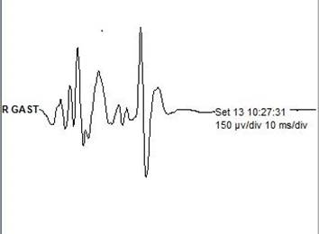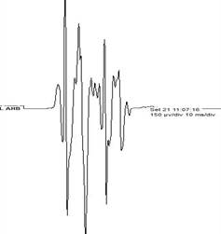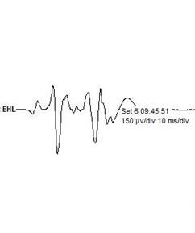

Displayed at 150µV/div

Figure 3. The Variable Quality of MEP Responses

Well Formed Moderately Formed Poorly Formed/Unacceptable
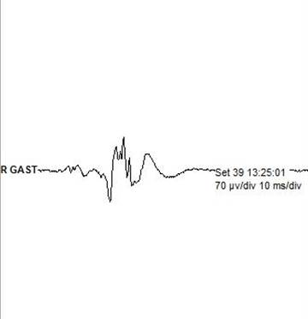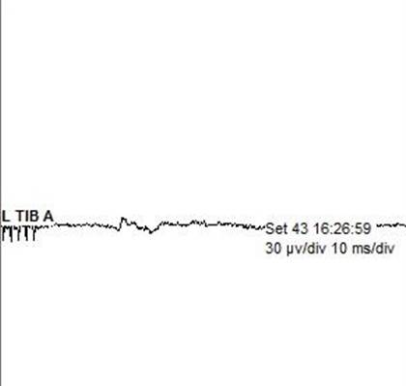

Responses Displayed at Different Sensitivities to Optimize Viewing

Figure 4. Moderately Complex but Acceptable MEP Responses for Nerve Root Monitoring

Moderately Complex but Acceptable MEP Responses

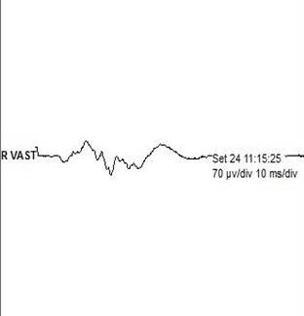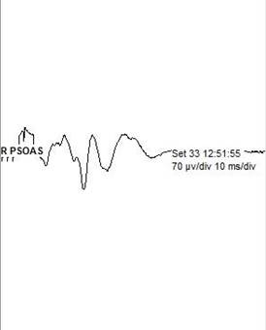

Displayed at 70µV/div

Figure 5. Poorly Formed Unacceptable MEP Responses for Nerve Root Monitoring

Poorly Formed Unacceptable MEP Responses

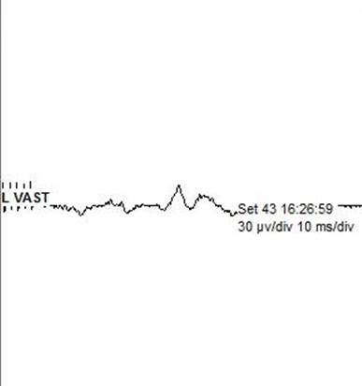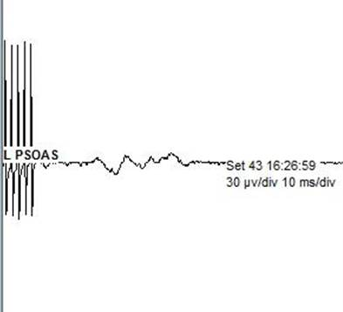

Displayed at 30µV/div

Figure 6. Baseline SSEP and MEP Responses

Figure 7. Loss of SSEP and MEP Responses
Total loss of SSEP responses compared to baseline waveforms

Figure 8. Partial Return of SSEP and MEP Responses Following Decompression

Partial return of SSEP waveforms compared to baseline

Table 1. Cases of Interest Patient Data
Recovered by F/U Visit | Post-Op Neurologic Status Change | Did MEP Response Improve | Stagnara and outcome | Surgical Intervention | Suspected Cause of Data Change | SSEP Changes | MEP Muscles Affected | Procedure | Sex | Age
N/A | No Change | Yes | Yes, Neg | R L4-5 decomp | R L4-5 compression | R PTN | R AHB | PSF T3-S1 with TLIFs L4-S1 | F | 43
Yes | 3/5 Left TA | Yes | No | Left L5 root skeletonized | Left L5 compression | No | L TA and MG | PSF T4-S1 with TLIFs L4-S1 | F | 64
Yes | 3/5 Left TA and EHL | Yes | No | L5-S1 decomp | Annulus material compressing Left L5 root | Left PTN | L VM, TA, and bilateral EHLs | Attempted OLIF L4-S1, followed by PSF L4-S1 with L5-S1 TLIF | M | 68
N/A | No Change | Yes | No | Placed longer L4 screws | L4 screws causing spondylolisthesis reduction | No | L TA | PSF L4-ilium | F | 28
No | 3/5 Right TA and EHL | No | No | Removed Screws and decomp | Screw impingement  on root | No | Right TA, EHL, MG | PSF L4-S1 | M | 78
Yes | 3/5 Right TA and EHL | Yes | No | Decomp L5-S1 | Nerve root compression of L5-S1 | Right PTN | Right EHL, MG, AHB | Revision PSF T10-S1 with L5 PSO | F | 68
Yes | 2/5 Right lower extremity, 3/5 left VM | Yes | No | Decomp of L2-S1 | Compression of lumbar thecal sac during screw placement | Bilateral PTN | Bilateral VM, TA, EHL, AHB | PSF L2-S1 with decompression L2-S1 | M | 76
Yes | 2/5 bilateral dorsi & plantar flexion | Yes | Yes, pos bilaterally | Lumbar decomp | Lumbar stenosis | Left PTN | Right TA, EHL Left VM,TA,EHL, MG | PSF T12-ilium L5-S1 TLIF and L5 PSO | F | 58
Yes | 4/5 Right TA | Yes | No | Lumbar decomp | Positional increase in lumbar stenosis | Bilateral PTN | Bilateral TA,EHL,MG,AHB | Lumbar decompression L3-5 | F | 64
Yes | 3/5 Left TA | Yes | No | Left L5 root decomp | Left L5 root compression with correction | No | Left TA, EHL | Revision PSF T2-ilium with L5-S1 TLIF | F | 30
N/A | No change | Yes | No | Decomp of Right L4-5 | Compression secondary to pseudoarthrosis | No | Right VM, TA | PSF T3-S1 with L4-S1 TLIFs | F | 74
N/A | No change | Yes | No | Planned L3-S1 decomp | Positional increase in lumbar stenosis | Bilateral PTN | Bilateral AHB and Right TA,EHL | Lumbar decompression L3-S1 | M | 75
N/A | No change | No | No | Planned decomp of L1-3 | Positional increase in lumbar stenosis | Absent Lower Extremity SSEPs | Left IP,VM and Right MG | Lumbar decompression L1-3 | M | 60
N/A | No change | Yes | No | Removed cottonoid | Cottonoid compressing Right S1 root | No | Right MG | PSF T10-S1 with L3-4, L5-S1 TLIFs | M | 73

