Title page
Title: Analysis of the Associations of Polymorphism and Bone Mineral Density in Patients with Idiopathic Scoliosis
Authors: Miao Yu, MD, Xiaosong Yang, MD
Institution name: Peking University Third Hospital of China Beijing-People Republic of China
Corresponding author: Miao Yu
Mailing address: The 49 Huanyuanbei road, Haidian district of Beijing, 100191
Telephone number: +8618811769158
Email address: yxs8866@126.com

Structured Abstract
Study design
Exploratory research method: correlation study had been done to candidate gene loci, bone mineral density(BMD) and bone markers levels of Idiopathic Scoliosis(IS) patients.
Objectives
To analyze the associations of polymorphism, BMD and bone markers levels in patients with IS.
Summary of background data
IS is a serious 3-dimentional deformity which fosters threats on the patients' health. Researches have shown that BMD reduction is detected in the IS patients. Bone markers reflect the functional status of the skeleton. By measuring BMD, bone markers level and gene sequence of the IS patients, the study has discussed the relationship between BMD change, bone markers levels and gene polymorphism, which provides reference for further research on the mechanism of the reduction of BMD of the IS patients.
Methods
66 IS patients (26 males and 40 females) were enrolled in Peking University Third Hospital. 62 health person (21 males and 41 females) were enrolled as control group. Dual X-ray absorptiometry was applied to detect the BMD. Gene sequencing is conducted under the Sanger method. Measurements of the bone markers levels are conducted and comparison are made between the results and regular indexes.
Results
The gene loci rs28377268: chr9-98225056 is related to IS patients’ BMD based on linear regression analysis, for there is significant difference: the patient carrying allel G has relatively lower BMD. It is also related to IS patients’ osteocalcin and total procollagen type 1 amino-terminal propeptide (TP1NP) based on linear regression analysis, for there is significant difference: the patient carrying allel G has relatively higher osteocalcin and TP1NP.
Conclusions
SNP rs28377268 polymorphism influencing on lumbar spine BMD. And the SNP rs28377268 polymorphism was also found to be significantly associated with osteocalcin and TP1NP which may help to determine the mechanism responsible for low bone mass in IS. While, further studies on a larger number of subjects are required.

Keywords: Adolescent idiopathic scoliosis; Etiology; Bone mineral density; Polymorphism

Manuscript text
Introduction
Scoliosis is a serious 3-dimentional deformity of the spine occurring mostly in children and teenagers. With no effective prophylaxis methods, it fosters severe threats on the physical and mental health of the patients. BMD refers to the bone mineral weight per unit volume. The reduction of BMD is reasonable in senior citizens, while rare in teenagers. Burner et al. firstly asserted that association was found between the reduction of BMD and the occurrence of scoliosis. Thereafter, researches have shown that the whole-body BMD reduction is also detected in the axial and peripheral skeleton. And, the condition of low BMD may exist through the whole process of the development of scoliosis. Bone markers is one biochemical indexes of bone metabolism that can be detected in humor. The correspondent expression in the metabolic activity of the osteocyte and osteoclast by the possible but different combination in the bone formation and the bone resorption of the bone markers reflect the functional status of the skeleton.
Current researches on the mechanism of the BMD reduction of the scoliosis patients focus mainly in the following three aspects: biomechanics, gene polymorphisms, signal transduction pathway. Several of these studies have reported that the occurrence of scoliosis and the reduction of BMD are affected by genetic factors. Furthermore, a certain number of scoliosis patients have also shown associated symptoms of low bone mass, which indicates that the genetic locus related to the reduction of BMD may also have influence on the occurrence and development of scoliosis. However, most of the current studies are limited in the discussion of the association between scoliosis and gene polymorphisms as well as the association between the change of BMD and gene polymorphisms. There lacks prospective and explorative research on the association between the change of BMD of the scoliosis patients and gene polymorphisms, and the blank explanation of the mechanism of the change of BMD of the scoliosis patients lead to the lack of effective prophylaxis methods and treatment of scoliosis in clinical practice.
Based on the reports of some highly qualified Genome-wide association studies and and META researches, relevant genetic locus of the reduction of BMD are selected as candidate genetic locus thus to investigate the relationship between the change of BMD of the scoliosis patients, the bone markers of the scoliosis patients and the genotype of these genetic locus. In our preliminary study, it is discovered that there exists salient association between genetic locus rs28377268, gene polymorphisms of chr9-98225056 and the BMD and the osteocalcin of the scoliosis patients. This finding is of instructive significance for further study. By discussing the relationship between the change of BMD of the scoliosis patients, the bone markers of the scoliosis patients and gene polymorphisms, study on the mechanism of the reduction of BMD of the scoliosis patients will be further conducted, which will in return provide theoretical basis for the clinical prevention, diagnosis and treatment of scoliosis with the reduction of BMD.
Thus, multiple genetic pathogenic factors can be found in both scoliosis and BMD reduction, meanwhile quite a number of scoliosis patients has shown BMD reduction symptoms, which indicates that the gene loci related to BMD reduction may also have effects on scoliosis development. By analyzing the relationship between BMD change in scoliosis patients and gene polymorphism, bone metabolism and related gene loci’s polymorphism, bone metabolism and scoliosis development, the study tries to reveal the mechanism that drives BMD reduction in scoliosis patients, which helps to provide theories for clinical preventions, diagnosis and treatment for BMD reduction related scoliosis.

Materials and Methods
Exploratory research method: Correlation study had been done to candidate gene loci and BMD of scoliosis patients to further explore the relationship between BMD change in scoliosis patients and gene polymorphism, and to see if connection exists in BMD change of scoliosis patients and certain gene loci, bone metabolism and related gene loci’s polymorphism, bone metabolism and scoliosis development.
From January 2015 to March 2016, 66 scoliosis patients, 26 males and 40 females, were enrolled in Peking University Third Hospital. The diagnosis of these patients were judged comprehensively through clinical symptoms and signs as well as necessary assistant examinations. All subjects are ensured free of the history of endocrine diseases, connective tissue abnormalities and bone metabolic diseases and long-term mobility limitation. Besides, none of the subjects have taken drugs that can influence bone metabolism or received any kind of treatment or tried braces or orthosis of any form that may set limitation to physical movements. And 62 health person, 21 males and 41 females, were enrolled as control group. And corrected heights for patients were calculated using Bjure’s formula. Log y = 0.011x - 0.177, where y is the loss of trunk height (cm) due to a deformed spine and x is the greatest Cobb angle of the primary curve. The body mass indices (BMIs) were calculated by dividing weight (kg) by uncorrected height squared (m2).
Based on the reports of some highly qualified Genome-wide association studies and and META researches, relevant genetic locus of the reduction of BMD are selected as candidate genetic locus: p. Gly14 Ala, rs 760743075; p.His 305Gln, rs 121909798; PTCH1, rs 28377268; RSPO3, rs 577721086; WLS, rs 2566752; IDUA, rs 6831280; genetic locus associated with scoliosis: AJAP1, rs 241215; 2q36.1 between PAX3 and EPHA4, rs 13398147; 18q21.33 near BCL-2, rs 4940576; 10q24.32, rs 678741. Gene sequencing is conducted under the Sanger method. Extensive attention is paid to genetic locus rs28377268: chr9-98225056.
To study the association between the change of BMD of scoliosis patients and gene polymorphisms: dual X-ray absorptiometry (Hologic Discovery A, Bedford) was applied to detect the BMD of the lumbar vertebrae (LSBMDs) and femoral neck of the scoliosis patients. LSBMDs were measured at L1–L4 in anterior-posterior view. It may be difficult to measure spinal BMD reliably because of the scoliotic curvature. To minimize this problem, the amount of spinal rotation in patients was determined by pre-scanning the spine and measuring LSBMD in the neutral position. Thus compare the results with regular indexes; thereafter conduct gene polymorphism assess on the candidate genetic locus.
Measure the content of bone marker (E601 type fully automated electrochemiluminescence immunoassay analyzer, Roche), and analyze the associativity between the bone metabolism and the gene polymorphisms of the relevant genetic locus as well as the development of scoliosis. Measurements of 1,25-Dihydroxyvitamin D3, TP1NP, osteocalcin, parathyroid hormone and β-crosslaps are conducted and comparison are made between the results and regular indexes, thereafter conduct gene polymorphism assess on the candidate genetic locus.
SPSS 23.0 (SPSS Inc., Chicago, IL) was used for statistical analysis. Results are presented as mean ± standard deviations. The Hardy-Weinberg equilibrium was tested for each SNP in the patient. Frequency distributions of genotypes in patients and controls were compared using the t test and linear regression based association study for each SNP studied. Inter-group comparisons were made using the Fisher test. Statistical significance was accepted for P values of <0.05.
Results
We have conducted statistical analysis and BMD measurements based on general information and have typed certain gene loci: p. Gly14Ala, rs760743075; p.His305Gln, rs121909798; PTCH1, rs28377268; RSPO3, rs577721086; WLS, rs2566752; IDUA, rs6831280. The result is given below:
Figure 1 shows the total spine X-ray of two volunteer patients in the scoliosis case group. IS fosters severe threats on the physical and mental health of the two patients.
The genotype frequencies of all studied SNPs were determined by screening DNA samples. The genotype frequencies of the two groups are summarized in Table 1. The genotype frequency distributions of all four polymorphic SNPs were in Hardy–Weinberg equilibrium. Comparisons of genotype frequencies of the four polymorphisms studied in IS patients and healthy controls revealed a significant difference for only the SNP rs760743075 polymorphism (P=9.54E-15).
Subject characteristics are presented in Table 2: the difference in age, BMI, cBMI and biochemical markers.
Table 3.2 shows the gene loci rs28377268: chr9-98225056 is related to scoliosis patients’ BMD based on linear regression analysis, for there is significant difference: the patient carrying allel G has relatively lower BMD (P = 0.006936). Table 3.3 and Table 3.4 show the gene loci rs28377268: chr9-98225056 is related to scoliosis patients’ osteocalcin (P = 0.02505) and TP1NP (P = 0.01652) based on linear regression analysis, for there is significant difference: the patient carrying allel G has relatively higher osteocalcin and TP1NP. It is indicated that gene loci rs28377268: chr9-98225056 is related to both BMD, osteocalcin and TP1NP of scoliosis patients.

Conclusions
We examined the association between gene polymorphisms and BMD in Chinese with scoliosis. We found SNP rs28377268 polymorphism influencing on LSBMD. Therefore, early diagnosis of the disease using well-known genetic markers will provide beneficial information regarding individual susceptibility to low bone mass and may help high-risk individuals to take precautions against further reduction of bone mass.
And the SNP rs28377268 polymorphism was also found to be significantly associated with osteocalcin and TP1NP which helps to determine the mechanism responsible for low bone mass in scoliosis. While, further studies on a larger number of subjects are required.

Discussion
Researches have shown that BMD reduction and the change of bone markers level are detected in the IS patients. While, the precise mechanism of bone loss and the change of bone markers level in IS patients is unclear. Most of the current studies are limited in the discussion of the association between scoliosis and gene polymorphisms as well as the association between the change of BMD and gene polymorphisms. However, there are no prospective and explorative researches on the association between the change of BMD and bone markers level of the scoliosis patients and gene polymorphisms. Multiple genetic pathogenic factors can be found in both scoliosis and BMD reduction, meanwhile quite a number of scoliosis patients has shown BMD reduction symptoms, which indicates that the gene loci related to BMD reduction may also have effects on scoliosis development. By analyzing the relationship between BMD change in scoliosis patients and gene polymorphism, bone metabolism and related gene loci’s polymorphism, bone metabolism and scoliosis development, the study tries to reveal the mechanism that drives BMD reduction in scoliosis patients, which helps to provide theories for clinical preventions, diagnosis and treatment for BMD reduction related scoliosis.
Based on the reports of some highly qualified Genome-wide association studies and and META researches, relevant genetic locus of the reduction of BMD are selected as candidate genetic locus thus to investigate the relationship between the change of BMD of the scoliosis patients, the bone markers of the scoliosis patients and the genotype of these genetic locus. Genetic locus of the reduction of BMD : p. Gly14 Ala, rs 760743075; p.His 305Gln, rs 121909798; PTCH1, rs 28377268; RSPO3, rs 577721086; WLS, rs 2566752; IDUA, rs 6831280; genetic locus associated with scoliosis: AJAP1, rs 241215; 2q36.1 between PAX3 and EPHA4, rs 13398147; 18q21.33 near BCL-2, rs 4940576; 10q24.32, rs 678741. Gene sequencing is conducted under the Sanger method.
By comparing the genotype frequencies of the two groups are summarized, it shows that the genotype frequency distributions of all four polymorphic SNPs were in Hardy-Weinberg equilibrium. Comparisons of genotype frequencies of the four polymorphisms studied in IS patients and healthy controls revealed a significant difference for only the SNP rs760743075 polymorphism (P=9.54E-15). This study shows the gene loci rs28377268: chr9-98225056 is related to scoliosis patients’ BMD based on linear regression analysis, for there is significant difference: the patient carrying allel G has relatively lower BMD (P = 0.006936). It also shows the gene loci rs28377268: chr9-98225056 is related to scoliosis patients’ osteocalcin (P = 0.02505) and TP1NP (P = 0.01652) based on linear regression analysis, for there is significant difference: the patient carrying allel G has relatively higher osteocalcin and TP1NP. It is indicated that gene loci rs28377268: chr9-98225056 is related to both BMD, osteocalcin and TP1NP of scoliosis patients.
We found SNP rs28377268 polymorphism influencing on LSBMD. Therefore, early diagnosis of the disease using well-known genetic markers will provide beneficial information regarding individual susceptibility to low bone mass and may help high-risk individuals to take precautions against further reduction of bone mass. And the SNP rs28377268 polymorphism was also found to be significantly associated with osteocalcin and TP1NP which helps to determine the mechanism responsible for low bone mass in scoliosis. While, further studies on a larger number of subjects are required. While, further research on the mechanism are required.
It is reported that the PTCH1 gene encodes the receptor for sonic hedgehog (SHH), indian hedgehog (IHH) and desert hedgehog (DHH). On hedgehog binding, Ptch1 repression of the G-protein-coupled receptor Smoothened (Smo) is released and the hedgehog-signalling cascade is activated. In mice, it has been shown that the hedgehog-Patched1 signalling plays essential roles in many developmental processes, including osteoblastogenesis and chondrocyte differentiation. This pathway is also involved in homeostatic osteoblast activity and in regulation of bone remodelling.
SNP rs28377268 is in the PTCH1 gene. Researches show a pleiotropic effect of the rs28377268 SNP in the PTCH1 gene; independent associations with height and with BMD, both traits that reflect aspects of bone biology. The additional height signals that are found at the PTCH1 locus, however, do not show this pleiotropy in the data set. This difference may mirror differences of spatial and temporal control of PTCH1 expression and the hedgehog signalling pathway, on one hand bone growth, reflected by association with height and on the other hand bone development/maturation/homeostasis, reflected by association with BMD. The signal tagged by rs28377268 influences both. And Yingying Hong et al. found that exogenous SPARC promoted osteogenic differentiation of syndromic stromal cells with enhanced development of calcium nodules. In addition, bone mineral density tests showed that patients with NBCCS exhibit weak bone mass compared with sex and age-matched controls. It indicates that germline PTCH1 heterozygous mutations play a major role in bone metabolism in patients with NBCCS, in particular in those with PTCH1 protein truncation mutations. SPARC may represent an important downstream modulator of PTCH1 mediation of bone metabolism. Thus, on the basis of PTCH1 gene locus rs28377268 analysis, we are looking for the gene’s upstream and downstream bases and exploring its signaling pathways, downstream related mRNA and SPARC protein. And further studies on a larger number of subjects are required.

Figure legends
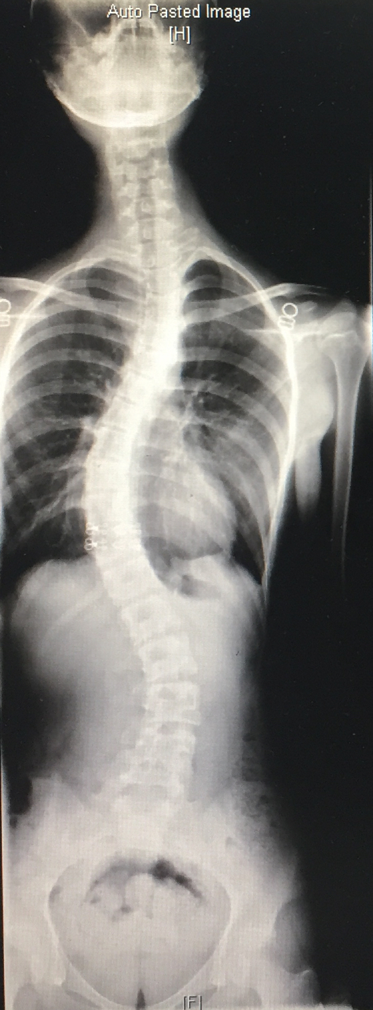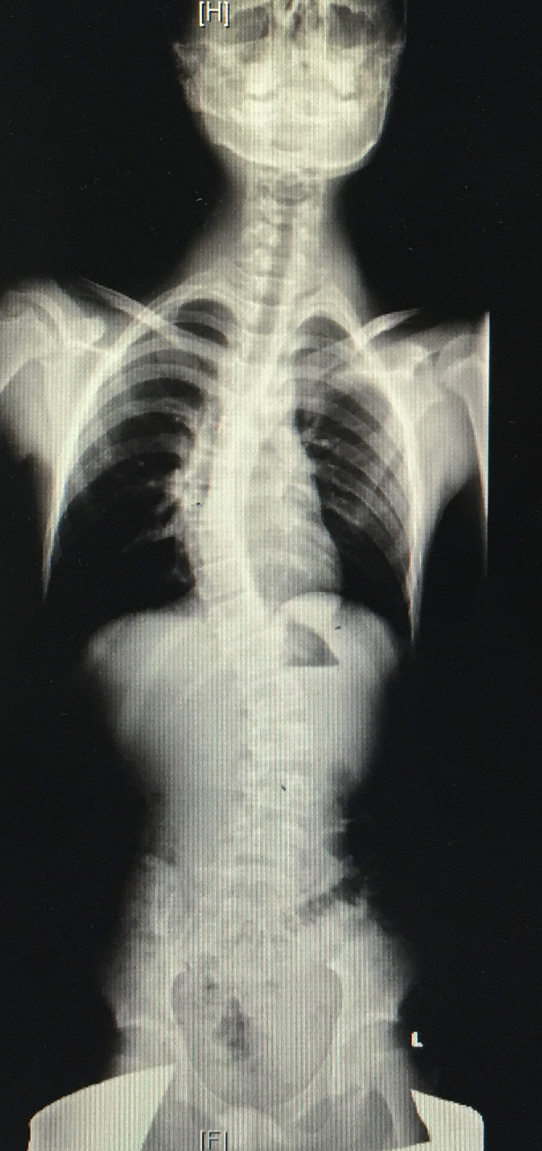
Fig. 1. Total spine X-ray of two volunteer patients

Table 1. Genotype frequency distributions in patients and healthy controls
SNPs | Patients (n = 66) | Control (n = 62) | P value (fisher's exact test)
rs2566752: chr1-68656697
TT | 22 | 12 | 0.2918
TC | 26 | 31
CC | 18 | 19
rs6831280: chr4-996165
AA | 0 | 0 | 0.193
AG | 14 | 21
GG | 52 | 41
rs28377268: chr9-98225056
TT | 2 | 4 | 0.2605
TG | 18 | 25
GG | 46 | 33
rs760743075: chr12-48272845
TT | 10 | 0 | 9.54E-15
TC | 30 | 0
CC | 26 | 62

Table 2. Phenotype distribution in patients.
Phenotype | patients(n = 66, mean ± sd)
Age (years) | 18.18 ± 13.01
Sex (1=male, 2=female) | 26/40
BMI (kg/m²) | 19.80 ± 3.91
cBMI (log BMI) | 2.96 ± 0.21
LSBMD | 0.79 ± 0.15
FNBMD-R | 0.68 ± 0.11
FNBMD-L | 0.66 ± 0.98
Osteocalcin | 78.76 ± 53.41
B.CTX | 1.30 ± 0.69
TP1NP | 463.60 ± 353.06
25(OH)D₃ | 13.79 ± 6.17
PTH | 36.51 ± 14.63
cBMI=correct BMI, log transform.

Table 3.2 Association of SNPs with related phenotypes.
Phenotype | SNPs Genotypes |  | Phenotype (mean±sd) | Effect Allele | Effect | Pvalue
LSBMD | rs2566752: chr1-68656697 | TT | 0.8365 ± 0.10 | T | 0.05151 | 0.1378
 |  | TC | 0.8035 ± 0.20
 |  | CC | 0.732 ± 0.10
 | rs6831280: chr4-996165 | AA | NA | A | 0.019 | 0.7769
 |  | AG | 0.81 ± 0.23
 |  | GG | 0.79 ± 0.13
 | rs28377268: chr9-98225056 | TT | 1.26 ± 0 | T | 0.1313 | 0.006936
 |  | TG | 0.83 ± 0.08
 |  | GG | 0.76 ± 0.14
 | rs760743075: chr12-48272845 | TT | 0.79 ± 0.10 | T | -0.0384 | 0.3249
 |  | TC | 0.76 ± 0.17
 |  | CC | 0.84 ± 0.14

Table 3.3 Association of SNPs with related phenotypes.
Phenotype | SNPs Genotypes |  | Phenotype (mean±sd) | Effect  Allele | Effect | Pvalue
Osteocalcin | rs2566752:  chr1-68656697 | TT | 59.44 ± 51.28 | T | -18.26 | 0.197
 |  | TC | 86.8 ± 55.2
 |  | CC | 94.33 ± 53.93
 | rs6831280:  chr4-996165 | AA | NA | A | 9.214 | 0.7592
 |  | AG | 86.5 ± 73.24
 |  | GG | 77.29 ± 51.03
 | rs28377268: chr9-98225056 | TT | 10 ± 0 | T | -42.89 | 0.02505
 |  | TG | 48.5 ± 39.44
 |  | GG | 92.67 ± 52.57
 | rs760743075: chr12-48272845 | TT | 97.2 ± 59.12 | T | 24.78 | 0.09009
 |  | TC | 92.09 ± 55.09
 |  | CC | 52.22 ± 42.04

Table 3.4 Association of SNPs with AIS-related phenotypes.
Phenotype | SNPs  Genotypes |  | Phenotype (mean±sd) | Effect Allele | Effect | P value
Osteocalcin | rs2566752: chr1-68656697 | TT | 59.44 ± 51.28 | T | -18.26 | 0.197
 |  | TC | 86.8 ± 55.2
 |  | CC | 94.33 ± 53.93
 | rs6831280: chr4-996165 | AA | NA | A | 9.214 | 0.7592
 |  | AG | 86.5 ± 73.24
 |  | GG | 77.29 ± 51.03
 | rs28377268: chr9-98225056 | TT | 10 ± 0 | T | -42.89 | 0.02505
 |  | TG | 48.5 ± 39.44
 |  | GG | 92.67 ± 52.57
 | rs760743075: chr12-48272845 | TT | 97.2 ± 59.12 | T | 24.78 | 0.09009
 |  | TC | 92.09 ± 55.09
 |  | CC | 52.22 ± 42.04

