Title page
Title: Propionibacterium acnes only survives in the presence of implants and causes late infections.
Authors: Yuta Shiono¹, Ken Ishii^{1, 2}, Kota Watanabe¹, Morio Matsumoto¹.

Institutions: ¹Dept. of Orthopaedic Surgery, School of Medicine, Keio University, Tokyo, Japan, ²Department of Orthopaedic Surgery, International University of Health and Welfare School of Medicine, Tokyo, Japan

Name and address for correspondence
Morio Matsumoto M.D.
Dept. of Orthopaedic Surgery, Keio University
Shinanomachi 35, Shinjuku-ku, Tokyo #160-8582, Japan
Tel 81-3-3353-1211
Fax 81-3-3353-6597
E-mail morio@sc.itc.keio.ac.jp

Introduction
It is recently reported that Propionibacterium Acnes (P. acnes) causes implant-associated infection (IAI) in orthopedic surgeries¹⁻³. We previously reported finding P. acnes in intraoperative specimens from 11 of 80 patients (14%) who underwent scoliosis surgery, although none of the patients had symptoms of infection (2010 SRS 45th annual meeting, Spine 2011)⁴. In this study, possible reasons for the infection not becoming established included 1) a false-positive detection of P. acnes due to contamination; 2) insufficient numbers of bacteria to establish the infection; or 3) the inability of P. acnes to grow in an aerobic environment in vivo. Thus, this clinical study did not clarify whether P. acnes could survive and cause IAI. Little is known about the kinetics of P. acnes in vivo. Here we investigated whether P. acnes causes IAI under the presence or absence of titanium implant.
Methods
In the model of osteomyelitis, P.acnes (ATCC No. 51277, Strain Designations VPI 9, 1.0 x10⁸ CFU/1μl) were inoculated into the femur of the adult mouse with (implant group, N=12) or without (control group, N=6) 0.5×8mm titan alloy bar. NIR-fluorescent bacterial detection probe which can only detect the living bacteria was injected intravenously, then P．acnes was tracked using bacterial optical imaging system for 6months. The biofilm formation on the implanted bars and histological tissues were observed under a microscope, fluorescent microscope using a kit that dyes living cells into green florescent (Cy2), and Electronic microscope. Anaerobic culture and PCR of purulent effusion from the infected site in the 6-month mouse was performed.
Results
During first 7days, NIR bacterial signal from P. acnes was clearly identified in the infected site in both groups. Afterward, the signal completely disappeared in the control group. Surprisingly, in the implant group, the bacterial signal was maintained over 6months (Figure 1). Microscopic findings showed that P. acnes survived in the biofilm around the implant, and active inflammation and abscess formation were shown over 3months in the implant group, but not in the control group. In the implant group, many P. acnes labeled with Cy2 that dyes living cells into green florescent were observed on the implant surface. In this biofilm, the bacteria labeled with Cy2 also expressed the NIR fluorescent dye, suggesting that the NIR fluorescent signals observed by optical imaging originated from the inoculated P. acnes detected by the bacterial probe. Scanning electron microscope (SEM) findings of the implant surface 6 months after surgery revealed many P. acnes and biofilms on the implant surface (Figure 2). Moreover, In the implant and control groups, effusions from femurs were cultured under anaerobic conditions for 2 weeks, resulting in the detection of eight colonies only in the implant group. Each colony was analyzed by PCR. All of the bacteria from the eight colonies were exactly the same strain of P. acnes (ATCC 51277, Strain Designations VPI 9) (Figure 3). These results show that P. acnes could survive only in the presence of an implant for 6 months without contamination and retained the capacity for growth in vivo. In other words, P. acnes observed in the biofilm on the implant surface might produce anaerobic conditions to survive.
Discussion
P. acnes is generally ubiquitous in the deep layers of the skin, in the upper respiratory and gastrointestinal tracts, and in eye mucosa⁵. When the mucous membranes and skin are incised using a scalpel or penetrated using a needle, the exposed tissues can be contaminated with endogenous flora. Several studies have shown that P. acnes causes SSI and late infections⁶⁻¹⁰, whereas other reports have suggested that the high rates of P. acnes-positive cultures is due to sample contamination¹¹. In addition, P. acnes is generally believed to have a low pathogenic potential. Therefore, whether P. acnes causes delayed SSI is controversial. Sampedro et al³. removed spinal implants from 22 patients with SSI, cultured the peri-implant tissues, and sonicated the fluid from the retrieved implants; they detected P. acnes in 9 (41%) of the 22 patients. In contrast, Levy et al¹². identified P. acnes using conventional aerobic and anaerobic culturing techniques in 41.8% (23 of 55) of consecutive patients who had no outward signs of infection and were undergoing primary shoulder arthroplasty. We previously reported detecting P. acnes in intraoperative specimens from 11 of 80 patients (14%) who underwent scoliosis surgery; none of the patients had symptoms of infection⁴. Thus, it was considered that P. acnes could be discounted as a pathogen in SSI and that high positive rates of P. acnes probably reflected false-positive results. Therefore, little was elucidated about the time course of P. acnes infections.
In the present study, we visualized and tracked the growth of living P. acnes using an optical imaging system. Ex vivo analysis of removed implants showed Cy2 labeled living-bacteria aggressively moving on the implant surface and expressing NIR fluorescent dye, suggesting that the NIR fluorescent signal observed by optical imaging originated from the inoculated P. acnes detected by the bacterial detection probe. Analysis of the time course in vivo showed that the inoculated P. acnes could not survive in the femur for >28 days without an implant. Interestingly, we found that P. acnes was able to survive for >6 months when the IAI was associated with a titanium alloy implant, suggesting that the presence of the implant was essential for the survival of the bacteria and the development of IAI. To the best of our knowledge, this is the first report demonstrating that P. acnes causes SSI only in the presence of an implant.
Conclusion
We have successfully proved that P. acnes cause delayed IAI over 6months in the osteomyelitis model. Interestingly, P. acnes could not survive for a long term without implant. To our knowledge, this is the first demonstration of delayed surgical site infection caused by P. acnes.

Figure and Figure legends
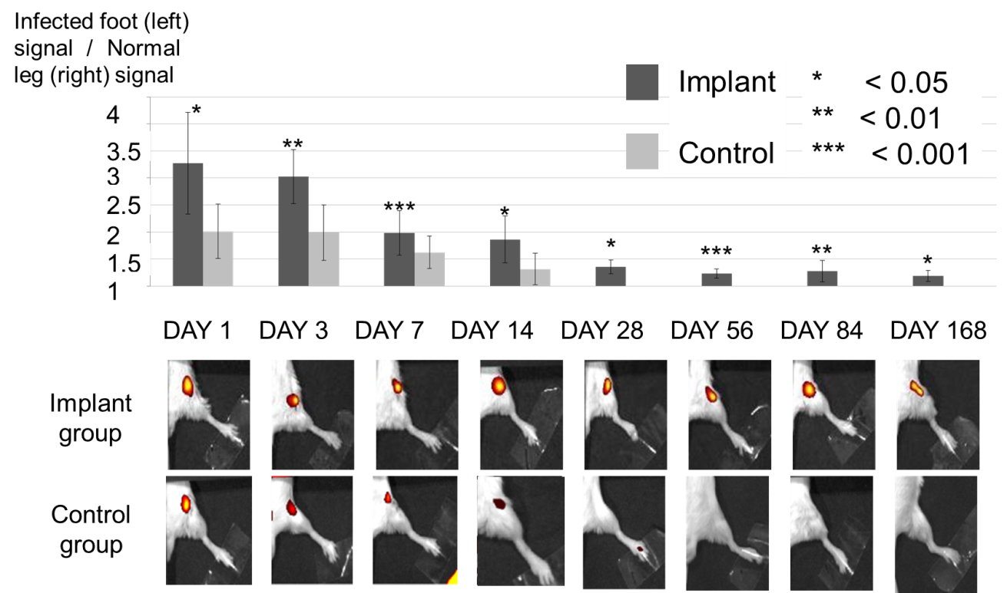
Fig.1.
Microscopic findings showed that P. acnes survived in the biofilm around the implant, and active inflammation and abscess formation were shown over 3months in the implant group, but not in the control group. The bacteria labeled with Cy2 also expressed NIR fluorescent dye, suggesting that the NIR fluorescent signal observed by optical imaging were expressed from inoculated P. acnes.

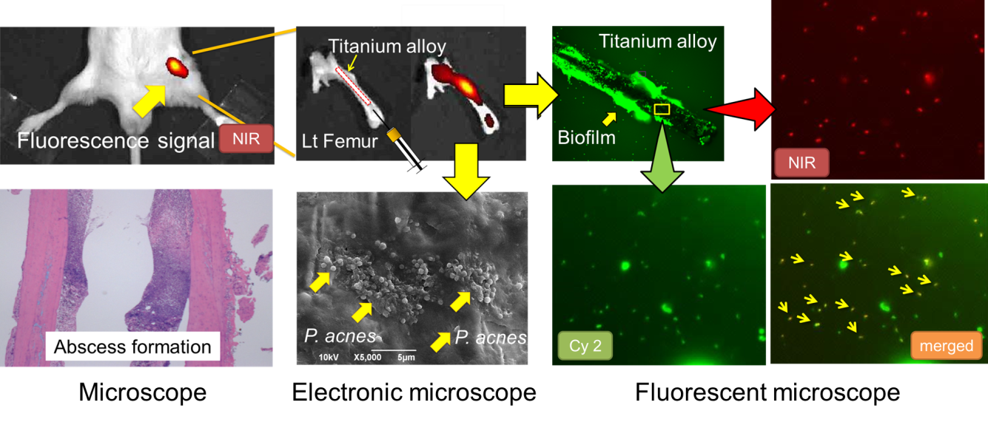
Fig. 2. Time course of optical imaging of P. acnes osteomyelitis with or without implant
NIR-fluoresence signals from the bacterial probe were successfully detected at the infected area. Signals were sequentially measured on days 1, 3, 7, 14, 28, 56, 84 (3 months), and 168 (6 months) after the inoculation in the implant group (implant +) (N = 12) and the control group (implant −) (N = 6). In the control group, clear signals were detected only for the first 14 days and the signal had completely disappeared within 28 days, indicating that the inoculated P. acnes could not survive for >28 days in this model. In contrast, signals in the implant group were detected 6 months after the P. acnes inoculation. At each time point, fluorescence ratios calculated from bacterial PIs in the implant group were significantly higher than those in the control group (p < 0.05 each). Means ± standard deviation (SD) are shown.

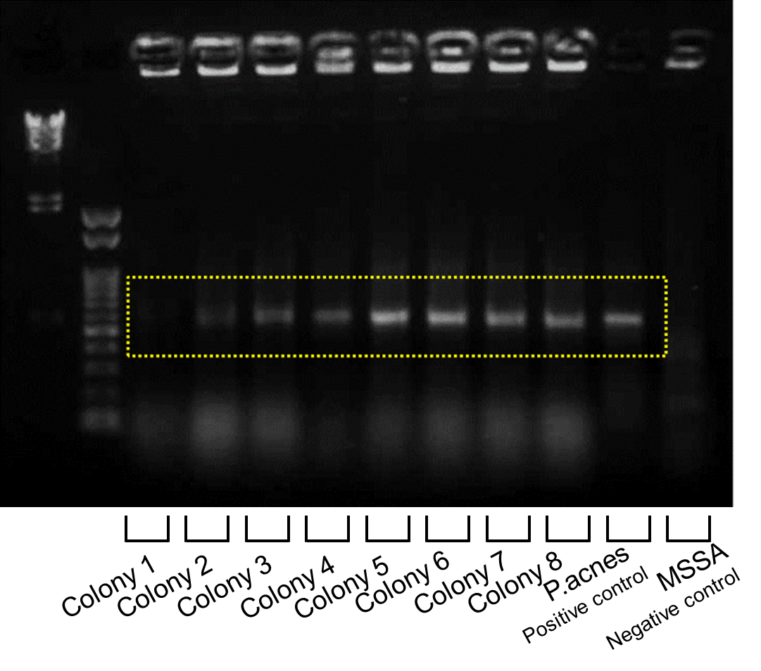
Fig. 3. PCR-confirmed genetics of the P. acnes obtained from femur specimens 6 months after inoculation
Six months after inoculation, purulent effusions from infected femurs were cultured under anaerobic conditions for 2 weeks; 8 colonies were obtained and were confirmed to be exactly the same strain of P. acnes (ATCC 51277, Strain Designations VPI 9) by PCR analysis, showing that P. acnes could survive for 6 months only in the presence of an implant.

References
1 Richards, B. R. & Emara, K. M. Delayed infections after posterior TSRH spinal instrumentation for idiopathic scoliosis: revisited. Spine (Phila Pa 1976) 26, 1990-1996 (2001).
2 Bayston, R. et al. Biofilm formation by Propionibacterium acnes on biomaterials in vitro and in vivo: impact on diagnosis and treatment. J. Biomed. Mater. Res. A 81, 705-709, doi:10.1002/jbm.a.31145 (2007).
3 Sampedro, M. F. et al. A biofilm approach to detect bacteria on removed spinal implants. Spine (Phila Pa 1976) 35, 1218-1224, doi:10.1097/BRS.0b013e3181c3b2f3 (2010).
4 Shiono, Y. et al. Sterility of posterior elements of the spine in posterior correction surgery. Spine (Phila Pa 1976) 37, 523-526, doi:10.1097/BRS.0b013e318224d7b2 (2012).
5 Perry, A. L. & Lambert, P. A. Propionibacterium acnes. Lett. Appl. Microbiol. 42, 185-188, doi:10.1111/j.1472-765X.2006.01866.x (2006).
6 Noble, R. C. & Overman, S. B. Propionibacterium acnes osteomyelitis: case report and review of the literature. Journal of clinical microbiology 25, 251-254 (1987).
7 Carricajo, A. et al. Propionibacterium acnes contamination in lumbar disc surgery. J. Hosp. Infect. 66, 275-277, doi:10.1016/j.jhin.2007.04.007 (2007).
8 Nisbet, M., Briggs, S., Ellis-Pegler, R., Thomas, M. & Holland, D. Propionibacterium acnes: an under-appreciated cause of post-neurosurgical infection. J. Antimicrob. Chemother. 60, 1097-1103, doi:10.1093/jac/dkm351 (2007).
9 Tribus, C. B. & Garvey, K. E. Full-thickness thoracic laminar erosion after posterior spinal fusion associated with late-presenting infection. Spine (Phila Pa 1976) 28, E194-197, doi:10.1097/01.BRS.0000062005.15715.C2 (2003).
10 Petrini, B., Welin-Berger, T. & Nord, C. E. Anaerobic bacteria in late infections following orthopedic surgery. Med. Microbiol. Immunol. 167, 155-159 (1979).
11 Maccioni, C. B. et al. Low rate of Propionibacterium acnes in arthritic shoulders undergoing primary total shoulder replacement surgery using a strict specimen collection technique. Journal of shoulder and elbow surgery / American Shoulder and Elbow Surgeons ... [et al.] 24, 1206-1211, doi:10.1016/j.jse.2014.12.026 (2015).
12 Levy, O. et al. Propionibacterium acnes: an underestimated etiology in the pathogenesis of osteoarthritis? Journal of shoulder and elbow surgery / American Shoulder and Elbow Surgeons ... [et al.] 22, 505-511, doi:10.1016/j.jse.2012.07.007 (2013).

