Disc Degeneration at Distal Unfused Segments after posterior Spinal Fusion in Patients with AIS Lenke Type 1 or 2: A 20-Year Follow-up Study

Kazuki Kawakami ¹⁾, Ayato Nohara²⁾, Saito Toshiki¹⁾ , Ryoji Tauchi¹⁾,

Tetsuya Ohara¹⁾, Noriaki Kawakami¹⁾

1) Meijo Hospital Department of Orthopedics and Spine Surgery
2) Tokyo Shinjuku Medical Center Department of Spine Surgery

Abstract

Background:
Evaluation of discs via MRI in the long-term in patients with adolescent idiopathic scoliosis (AIS) who were surgically treated is of great concern. While some studies have evaluated Disc Degeneration (DD) using MRI, the issues regarding the non-serial non-consecutive nature persists. The purpose of this study was to investigate the occurrence of DD in distal unfused segments using MRI with a prospective fashion in patients with AIS during 20y FU period by comparing with an age-matched control cohort.
Materials: This was a retrospective cohort study. Out of 70 consecutive pts. with AIS LK1/2, who have undergone corrective fusion at single institution, 36 (FU rate 51%) met following inclusion criteria: 1) > postop. 15y FU, 2) serial lumbar MRI images, 3) coronal and sagittal X-ray Images. These pts. with an age at final FU of 36y were compared with an age-matched control group of 51 volunteers. No significance existed between the cohorts with respect to age (p=0.11) and BMI (p=0.20). Lumbar DD was evaluated according to Pfirrman’s grading scale at every 5 years until final FU. Pts. were separated per LIV placement and DD at each placement was also considered. HRQOL using SRS-30 at 10 years postop. and final FU was analyzed per domain.
Results: A gradual increase in the number of DD was seen from PO5y to final FU starting at 30％ at PO5y, 56％ at PO10y, 68％at PO15y and 77％ at PO20y. Significant difference (p＝0.0005) was seen in the number of degenerated discs among the surgical group at PO20y and the control. Severe DD (grade ≧4) was most common at L5/S in the surgical whereas equal amount of severe DD was seen at L4/S and L5/S in the control along with a lower occurrence rate. Modic change was seen in 9 patients who had DD of grade 4 or 5 at 20- year postoperatively, while 2 patients had exhibited. Lumbar scoliosis throughout the follow-up period can influence the occurrence of DD at unfused lower lumbar segments. Mean SRS-30 at final FU was 3.8 overall with a lower self-image score than other domains. Marital status at PO20y had shown to be significantly correlated (p>0.07) to mental score at PO20y while other domains did not show such correlation.
Conclusion: An increase in occurrence of DD during the postoperative period of 20 years in patients with AIS Lenke 1 or 2 still did not have a major impact on their ADL, albeit with implications on biopsychosocial factors, while DD occurred more frequently at PO20y in a more severe manner than at PO10 and in the control.

Introduction

Adolescent Idiopathic Scoliosis (AIS) is a condition that results in a structural alteration of the spine through growth during adolescence that affects approximately 3-4% of the population (1-5).
Long-term follow-up studies of AIS are extremely important as patients are still young, and warrants further curve progression and consequential degenerative changes through their life. Extensive long-term natural history studies do exist (6-10), and it has been found that patients who exhibit curves greater than 40-50 degrees can continue to show progress in their curves throughout adulthood and can have significant consequences with pain and disability (9,10). Surgical correction is crucial for patients with progressive curves that cannot be controlled by brace treatment; conversely, to assess the outcomes for surgical treatment of AIS, postoperative long-term studies are required.
Unfortunately, while several long-term follow-up studies do exist for patients who have been surgically corrected, much of these studies were done on patients who have undergone surgical correction using non-modern systems such as Harrington Rods that utilizes distraction as the main method of corrections (11-20). To this day, the number of long-term studies that have examined clinical outcomes of patients who have undergone posterior correction with modern corrective methodologies that employ rod rotation maneuvers has been limited (21-27). Furthermore, most of these existing long-term studies have generally been non-serial, non-consecutive studies in design, and included patients who have been followed-up with either a clinic visit or a questionnaire when they were identified retrospectively without observational data throughout the follow-up period.
Another important consideration is in the number of unfused segments that is spared when fusion is done. Discs are known to degenerate as part of natural aging process (28). With fewer discs available to disperse the force in a fused spine, it is only natural to believe that discs are prone to more degeneration postoperatively. For this reason, evaluation of discs via MRI in the long-term is of great concern. While some studies have evaluated Disc Degeneration (DD) using MRI, the issues regarding the non-serial non-consecutive nature persists (20, 21, 23, 25, 26). An exception to this are studies by Nohara et al. which examined patients up to 10-years follow-up consecutively every 5 years postoperatively in a serial manner using MR and X-P radiographs, along with SRS-30 questionnaires at their final-follow-up (27,29). They have Indicated L4 tilt, lumbar scoliosis, number of mobile segments, and placement of Lower Instrumented Vertebrae (LIV) to have a significant effect in affecting the rate of DD at distal unfused segments at 10-years postoperatively. Even at 10 years; however, no correlation between clinical outcomes and DD was found, and they have warranted further long-term studies to assess degenerative changes that actually affect patients’ activities of daily living (ADL). This is understandable as most patients are still in the 20s, and therefore, much of the expected degenerative changes has yet to come in these patients.
Based on the data collection done by Nohara, et al, follow-up has been continued in the same manner to date, with the longest postoperative follow-up among all curve types extending up to 25 years. Out of these, patients with Lenke type 1 & 2 curves have been specifically examined in this study. The purpose of this study was to investigate the occurrence of DD in distal unfused segments in patients with AIS Lenke Type 1 or 2 with an average follow-up period of 20-years postoperatively by comparing with an age-matched control cohort.

Material and Method

This study has received IRB approval from Meijo Hospital. While this study is a retrospective cohort study, patient data (radiographs and clinical data from each visit) for this study was obtained in a scheduled manner with a pre-planned goal of assessing changes in DD over time since the time when patients first received surgeries to mimic that of a prospective design.
This study involved patients with Adolescent Idiopathic Scoliosis (AIS) with Lenke-1 and 2 curves who have undergone corrective surgery by a single surgeon during 1990-1998. All surgeries with posterior corrective fusion with and without anterior release that used derotation maneuver conducted by this surgeon was considered. A consecutive series of 70 patients was identified under these criteria.
Out of included patients, those who have had a minimum follow-up period of 15 years, available serial MR Images and Full Spine Coronal and Sagittal X-Ray images were included in this study. Mean follow-up period was 19.8 ±2.1 years.
36 patients (51%); 31 females and 4 males were found to fit the criteria and was included as the Surgical Group. To assess HRQOL, SRS-30 questionnaire was obtained from these patients at postoperative 10-years and at final follow-up of each patient. In addition, demographic data and relevant patient’s biopsychosocial factors such as marital status, prior labor during the postoperative follow-up period, and occupation were collected.
An age-matched control group consisting of 47 volunteers (3 Male, 44 Female) was recruited for this study and their MR images were obtained to assess differences in DD to that of the Surgical Group at postoperative 20-years. These volunteers consisted of nurses who were identified to have no previous surgeries involving the spine with no other comorbidities that may influence DD. The Control Group was compared against the Surgical Group with regards to Age, Height, Body Weight, and BMI.
The surgical group had an average age of 36.2, height of 158.2 cm, body weight of 48.9 kg, and BMI of 19.3. In comparison, the control group had an average age of 34.9, height of 158.7 cm, body weight of 51.2 kg, and BMI of 20.2. No significant difference was found in any of the parameters among the two groups; age (p=0.1101), height (p=0.6787), body weight (p=0.3585), and BMI (p=0.1999).

Statistical Analysis
Statistical Analysis was conducted with JMP 13.0 Statistical Analysis Software. Analysis for non-parametric data was conducted using Wilcoxon/Kruskal-Wallis Analysis and parametric data was conducted using T-Tests.

MRI Images
In general, MR images were obtained separately for each patient at approximately 5 year intervals postoperatively until final follow-up. All obtained images for both the Surgical Group and the Control Group were assessed for DD at each disc level under the Pfirrman’s Criteria (30) by 2 separate surgeons including 1 surgeon who did not partake in the patient’s care. In this study, all discs that was identified as Grade I and II under the Pfirrman’s criteria was considered as DD-, and Grade III-V as DD+. During the analysis, patients who have exhibited DD+ was grouped as the DD+ Group, and DD- as the DD- Group.

X-Ray Images
Just as the case for MR images, sagittal and coronal X-Ray images were obtained preoperatively, and at approximately 5 year intervals until final follow-up. Coronal parameters such as upper, thoracic, and lumbar curves, L4 tilt, as well as sagittal parameters such as thoracic kyphosis, lumbar lordosis, and sacral slope was measured. LIV placements and number of mobile segments were also noted and used for analysis. Changes to curve parameters and correction rates over the years were further analyzed. In addition, LIV and the number of mobile segments in each patient was recorded and also used for analysis.

SRS-30 and Low back pain
Health-Related Quality of Life was evaluated using SRS-30. SRS-30 scores were acquired from each patient at approximately 10 years postoperatively and at final follow-up. Obtained scores were analyzed further per domain (Function, Pain, Self-Image, Satisfaction) and by the total score. Presence of low back pain reported by each patient at 5-year intervals were noted separately. Relationship between SRS-30 Domain scores to biopsychosocial factors such as marital status, previous childbirth was analyzed.

Results

Mean age at when patient received their surgeries were 16.1 ± 2.5, and mean age at final follow-up of all included patients was 36.2 ± 3.3. Marital status at final follow-up was considered; there were 10 patients who were single, 23 patients who were married, and 3 patients who had experienced divorce. Patients had shown a mild increase in BMI from 19.3 ± 2.0 at immediately postoperatively to 20.4 ± 2.5 at final follow-up.

Scoliosis in the Surgical Group
Mean scoliosis magnitude at each measured interval has been tabulated under Table 1. As expected, a gradual increase in thoracic and lumbar scoliosis due to losses in correction was noted in the subsequent follow-up period postoperatively. Mean thoracic scoliosis magnitude preoperatively, postoperatively, 5-year postoperatively, 10-year postoperatively and at final follow-up were 57.5 ± 8.6, 23.5 ± 8.8, 28.3 ± 7.4, 29.1 ± 8.1, and 30.7 ± 15.0, respectively. Lumbar scoliosis magnitude preoperatively, postoperatively, 5-year postoperatively, 10-year postoperatively and at final follow-up was 36.1 ± 10.1, 14.7 ± 8.3, 18.9 ± 9.0, 19.2 ± 8.2, and 19.9 ± 9.0, respectively. L4 tilt had shown a slight increase throughout as well, as expected with an increase in overall scoliosis magnitude.
Sagittal parameters have also been tabulated under Table 2. Thoracic Kyphosis have increased to a modest degree from 28.0 ± 8.2 to 34.8 ± 10.8 by the final follow-up period. Changes to lumbar lordosis and sacral slope was also seen but was much less prominent.
LIV placement of each patient was examined. LIV placements were between T12 to L3, with 14 patients at L1, 8 patients at L3, 7 patients at both L2 and T12. LIV placement had differed with specific lumbar modifier (Figure 1). For example, more than 50% of patients with Lumbar modifier A had LIV placed at L1, while more than half of the patients with lumbar modifier C had LIV placed at L3.

MRI
DD had gradually increased in the follow-up period. Initially at 5 years postoperatively, 30% of the patients had shown DD, 56% by 10 years postoperatively, 68% by 15 years postoperatively, and 77% by 20 years postoperatively (Figure 2). Distributions in the grade of DD among the intervertebral disc levels had changed through the years. Most DD at 5 years postoperatively was of Grade II or Grade III if any, and all grade III was found at L4/5 and L5/S. At 10 years postoperatively, Grade III degeneration started to appear at L3/4. By the follow-up, Grade V degeneration started to appear at L5/S, with an increasing number of grade IV-V degeneration at L4/5 (Figure 3). Modic change was seen in 9 patients who had DD of grade 4 or 5 at 20- year postoperatively, while 2 patients had exhibited Modic change relatively earlier in the postoperative course; one was at postop. 5 years and the other at postop. 10 years (Figure 2). The segment of where Modic change had occurred was at L5/S in 8 patients (type 1: 5, type 2: 3), L3/4 in two (type 1:1, type 1 & 2: 1), and L4/5 in 2 (type 1:2).

DD in the control group was found in 60% of all discs. It was most frequent at L4/5 (43%) followed by L5/S (38%) and much less frequently at higher levels (Figure 4b). When comparing DD amongst the Control group and the Surgical Group at 20 Years postoperatively, there was significantly greater number of DD in the Surgical group (p=0.0005), consisting of a 22% greater proportion of DD. Alongside this difference, significant differences were also found in the number of DD at most vertebral level in the 2 groups (L1/2: p=0.0469, L3/4: p=0.0023, +4/5: p=0.0489, L5/S: p=0.0017) except at L2/3 (p=0.1522). Furthermore, the distributional pattern of DD at each level was different. Number of DD was greatest at L4/5 in the Control Group; however, it was greatest at L5/S in the Surgical Group (Figure 4a,b).

Comparison between DD- and DD+

Curve parameters of patients acquired from coronal and sagittal X-P radiographs at preoperatively, postoperatively and at final follow-up have been compared with respect to their DD status at 5-year intervals. Out of all curve parameters, final follow-up lumbar scoliosis was significantly different (p<0.05) amongst DD- and DD+ starting early as 5-year postoperatively to 15-year postoperatively, but not at 20-year postoperatively. Immediately post-operative lumbar scoliosis was found to be significant (p<0.05) only at 10-year postoperatively, with a strong trend (p=0.0525) at 5-year postoperatively, but not at further follow-up periods. Preoperative lumbar scoliosis was not significant in DD status at any of the follow-up periods. L4 tilt at immediately postoperatively and at final follow-up was also found to be significant (p<0.05) at 5-year postoperatively, but no significance was found at any further follow-up period. No significant difference was found in any other curve parameter with respect to DD status at all follow-up durations (Table 3).

LIV placement was compared to the occurrence of DD (Figure 5). DD was found to increase when moving distally in the vertebral column. For T12, no DD existed at 5 years postoperatively but by 20 years postoperatively, there were more patients with DD than without. This was most prominent at more distal segments, and in L3, although there were equal number of patients with and without DD, by 20 years postoperatively, there were no patients without DD. As more distal placement of LIV is inversely related to the number of mobile segments, and therefore the difference in the number of mobile segments was also compared in DD- and DD+ groups (Table 4). At all follow-up period beyond 5 years postoperatively, number of mobile segments was significantly different (p<0.05) in DD- and DD+ groups.

SRS-30
SRS Domains were collected at patients’ 10 and 20 year-follow-up postoperatively. Each domain was computed separately and their values at 10-year and 20 years was correlated to each other. Similar results were found in all domains (Pain, Self-image, Mental Health, Satisfaction) at both 10 years and 20 years postoperatively.
Scores were also compared with respect to the patient’s DD status. Mean scores of each domain per DD status (DD+ and DD-) was compared at both 10 years and 20 years postoperatively (Figure 6). At 10 years postoperatively, no significant differences were seen between DD- and DD+ groups in any domain or the total score. Scores at 20 years, however, did not follow this trend, and had shown differences in the total score (p=0.0022) as well as at 2 domains. Patients with DD had significantly lower scores in both the Satisfaction (p=0.0091) and Self Image domains (p=0.0025).

SRS-30 domains of all patients at 20 years postoperatively was evaluated with respect to marital status. Marital status was separated amongst “Married” and “Single/Divorce.” In this set of patients, no patients had multiple marriages or death of their partner. While no significant difference was seen in the Total SRS-30 score, notable differences were seen in two domains (Figure 7). Patients who were single or had experienced previous divorce had significantly lower values in the Pain (p=0.0228) and Mental Health (p=0.0341) domains than those who were married. SRS-30 scores of patients who had previous childbirth and those that did not was also compared. No significant difference was found in all domains. Patients’ occupation was also considered, however, no significant difference in DD was also seen between desk worker and manual laborer.

Low Back Pain and QOL
DD was also examined with respect to the patients’ actual clinical complaints of Low Back Pain (LBP). Clinical complaints were obtained directly by a single spine surgeon (NK) who examined all patients at clinic included in this study. At 5-year postoperatively, there was a significant difference (p=0.0102) in the number of patients who have complained of LBP and had DD, to those that didn’t complain of LBP but no DD. This trend is still, to an extent present at 10 years postoperatively, with more patients who had DD complaining more of LBP than those that do not have DD (p=0.0310), albeit without statistical significance. By 15 and 20-year follow-up, there essentially is no difference in the number of patients who complained of LBP among those who had DD and those who did not (Figure 8). At 20 years, 27 patients have complained of either having LBP all the time or sometimes, whereas 9 patients reported that they do not have LBP. 8 out of 9 patients who had Modic changes had also reported LBP.

Discussion

Greater incidences of DD amongst patients who have undergone modern surgical correction is a known phenomenon that have become more apparent in the past few years as more long-term follow-up studies become available (20, 21, 23, 25, 26). Nevertheless, most studies with a follow-up period of greater than 10-years to date lacks continuous follow-up of patients at the clinic with scheduled MR and X-P radiographs. This study is unique in that it has included a consecutive series of patients at a single institution, with a follow-up rate of 51%, acquired MR and X-P radiographs at 5-year intervals, SRS-30 scores obtained at 10 and 20-year follow-up postoperatively, and compared DD to an age-matched control population consisting of volunteers without scoliosis.
DD is a phenomenon that occurs to a substantial degree in the normal aging process and wear and tear through weight-bearing in daily life (28). Likewise, this is seen in the surgical group where DD had increased in a gradual manner throughout the follow-up period, and by 20 years postoperatively, majority of the patient had exhibited DD. What is different; however, is the difference in both the rate and the pattern at which DD had occurred in the surgical group when compared to the control group.
Individuals in the control group had DD that had occurred most at L4/5 like those found in previous literature of DD found in normal populations (28). In the surgical group, although rates of DD were higher when moving distally down the vertebral column, it did not peak at L4/5 and instead its rate was greatest at L5/S1. This finding coincides with findings by Nohara, et al (27, 29), Green et al. (23), with greater rates of DD at L5/S1 at 10-years postoperatively. At the same time, it is also important to mention the heightened rates of DD at all levels in the surgical group than in the control group. This difference is likely to be induced by mechanical changes in load-bearing forces from fusion in the more proximal segments and alterations to load-bearing forces on the discs which may or may not be further affected by residual scoliosis that had either been not fully corrected or increased from losses in correction through the follow-up period. These interpretations can be supported that increased rate of occurrence of Modic change at 20 years postoperatively, as disc/end plate damage such as DD and hyperloading are known risk factors for Modic change (31,32,33). Stated differently, when Modic change of either type 1 or type 2 occurs alongside DD grade 4 or 5 during long-term follow-up period, it leads to mechanical stress on L5/S1, which likely are aggravated by the loss of cushioning of the discs due to DD.
Various factors that is considered during the surgical planning for surgical correction of scoliosis has been postulated to have an influence on the DD in the follow-up period (22, 24, 25, 26, 27, 29). These include number of mobile segments, LIV placement, curve magnitude preoperatively etc. By 20-year postoperatively, there were more patients who had exhibited DD than those that didn’t, at all levels of LIV placements between T12-L3 and DD had increased with lower LIV placements. Furthermore, all patients who had their LIV placed at L3 had DD by 10-years postoperatively. DD, therefore occurs much less when LIV is placed more proximally, and conversely with more mobile segments as evident with patients with LIV placed at T12; there were similar number of patients who had DD to those that did not have DD at 20-year postoperatively. This is consistent with findings in previous studies done with a follow-up period of 10-years (27).
Mobile segments had also been shown to significantly affect rates of DD as early as at 10 years postoperatively, and was found continuously throughout the rest of the follow-up period. More mobile segments resulted in lower rates of DD, which coincides with increased distribution of force amongst the lumbar discs resulting in lower weight bearing per disc. That being said, this “protective effect” that is seen with more mobile segments, wanes at least in part, with longer follow-up periods. This is especially evident when examining patients whose LIV was placed at L1 and L2. More than half of the patients experienced DD by 15 years postoperatively. This is quite different and disproportionate to that of what was found at 10 years postoperatively, in which many patients with LIV placed at L1 still had not shown DD.
In addition, lumbar scoliosis of patients in Lenke 1 and 2 at immediately post-operatively and at final follow-up were found to be significantly different with respect to DD status at 10-years postoperatively, and this trend is visible as early as 5-years postoperatively and continued to 15-years postoperatively. Stated differently, patients who had DD at 5-years postoperatively had a generally greater lumbar scoliosis at immediately postoperatively, and at final follow-up than those that did not have DD. A similar trend was found with L4 tilt to a less of a degree, as seen in the final-follow-up of DD+ patients at 5 years postoperatively. These findings are not seen at 20 years postoperatively, and it is likely that other factors with greater effect on DD, such as those pertaining to lifestyle and aging, obscure the effect that curve parameters such as lumbar curvature and L4 tilt have on DD status.
Surgical outcomes in relation to the patients’ perspective is important (13,16,19,22,26,29), and it is worth mentioning the notable differences in SRS-30 outcomes between DD+ and DD- obtained at 10-year and 20 years postoperatively. Differences in scores were seen despite strong correlations in almost all domains except for the Function domain, which still had equivalent mean scores at 10 and 20 years postoperatively. At 10 years, there was no significance in any domains nor in the aggregate score, yet at 20-years, significance was found in self-image, satisfaction, and in the total score. Differences in biopsychosocial factors experienced in the patients’ age group (20s vs 30s) may be different in nature and had led to differences in score.
This study also attempted to further explore differences in SRS-30 scores with respect to other biopsychosocial factors such as marital status, child births in female patients, differences in occupation, and any history of low-back pain obtained directly at the clinic. Marital status had shown significant effect in mental health and pain of the patients but not in other domains, where it further stresses the cognitive perception of pain and mental health to changes in living conditions.
There are several limitations to this study that is worth mentioning. First is the lack of preoperative MR images, although a substantial degree of changes can be inferred from beyond 5-years postoperatively. Second is the lack of SRS-22/30 preoperatively, making it difficult to observe actual changes in patients’ perspective before and after surgery. Third is that the study is of a small sample size and lacks statistical power in various aspects of the study even when significance was seen, such as when relating marriages and divorce to SRS-30 scores.
Limitation also existed in the examined population. Most patients had office-work related jobs and only few had occupations that involved manual labor, hence the difference in LBP and DD in those that do manual labor and office work may not be representative of the actual population. In addition, control was made up of nurses in the institution, which in overall, have more physical stress in the workplace than those with office-related occupational setting. Hence their DD may be greater than the normal population; nevertheless, the surgical group had exhibited more DD than the control group, and this further supports the notion that DD is greater in patients who had received surgeries than the normal population (28, 34).
Finally, this study also does not allow for comparison of DD in patients who had surgeries to those that did not but had lived with high grade scoliosis. As scoliosis and L4 tilt preoperatively was found in significance to rates of DD at 20-year postoperatively, it is suggestive that disturbances in curve parameters such as lumbar scoliosis and L4 tilt does affect DD rates even when patient did not receive surgeries.

Conclusion

An increase in occurrence of DD during the postoperative period of 20 years in patients with AIS Lenke 1 or 2 still did not have a major impact on their ADL, albeit with implications on biopsychosocial factors. Residual lumbar scoliosis throughout the follow-up period can influence the occurrence of DD at unfused lower lumbar segments. Balancing the dilemma between obtaining better correction of lumbar segments and allowing for more mobile segments is important when considering better clinical outcomes in AIS patients with Lenke 1 & 2 curves.

Reference
- Weinstein, S.L. Natural history. Spine 1999;24;2592-600.
- Kane WJ. Scoliosis prevalence: a call for a statement of terms. Clin Orthop Relat Res 1977;126:43–6.
- Lonstein JE, Bjorklund S, Wanninger MH, Nelson RP. Voluntary school screening for scoliosis in Minnesota. J Bone Joint Surg Am 1982;64:481-8.
- Lonstein JE. Adolescent idiopathic scoliosis. Lancet 1994;344: 1407–12.
- Weinstein SL, Dolan LA, Cheng JC, et al. Adolescent idiopathic scoliosis. Lancet 2008;371:1527–37.
- Nachemson A, A long-term follow-up study of non-treated scoliosis. Acta Orthop Scandinav. 1968;39: 466-476
- Nilsonne U, Lundgren KD. Long-term prognosis in idiopathic scoliosis. Acra Othop Scandinav 1968;39:456-465
- Weinstein SL, Iavala DC, Ponseti IV: Idiopathic scoliosis- long-term follow-up and progression in untreated patients. J Bone Joint Surg 1981;63-A: 702-712
- Weinstein SL, Dolan LA, Spratt KF, et al. Health and function of patients with untreated idiopathic scoliosis: a 50-year natural history study. JAMA 2003;289:559 – 67.
- Danielsson AJ. Natural history of adolescent idiopathic scoliosis: a tool for guidance in decision of surgery of curves above 50 . J Child Orthop 2013;7:37-41.
- Dickson JH, Erwin WD, Rossi D. Harrington instrumentation and arthrodesis for idiopathic scoliosis. A twenty-one-year follow-up. J Bone Joint Surg Am 1990;72:678–83.
- Cochran T, Irstam L, Nachemson A. Long-term anatomic and functional changes in patients with adolescent idiopathic scoliosis treated by Harrington rod fusion. Spine 1983;8:576 – 84.
- Danielsson AJ, Nachemson AL. Childbearing, curve progression, and sexual function in women 22 years after treatment for adolescent idiopathic scoliosis: a case-control study. Spine 2001;26:1449–56.
- Padua R, Padua S, Aulisa L, et al. Patient outcomes after Harrington instrumentation for idiopathic scoliosis: a 15- to 28-year evaluation. Spine 2001;26:1268–73.
- Helenius I, Remes V, Yrjonen T, et al. Comparison of long-term functional and radiologic outcomes after Harrington instrumentation and spondylodesis in adolescent idiopathic scoliosis: a review of 78 patients. Spine 2002;27:176–80.
- Gotze C, Liljenqvist UR, Slomka A, et al. Quality of life and back pain: outcome 16.7 years after Harrington instrumentation. Spine 2002;27:1456 – 63; discussion 1463–54.
- Mariconda M, Galasso O, Barca P, et al. Minimum 20-year follow-up results of Harrington rod fusion for idiopathic scoliosis. Eur Spine J 2005;14:854e61.
- Danielsson AJ, Romberg K, Nachemson AL. Spinal range of motion, muscle endurance, and back pain and function at least 20 years after fusion or brace treatment for adolescent idiopathic scoliosis: a case-control study. Spine 2006;31:275– 83.
- Danielsson AJ, Wiklund I, Pehrsson K, et al. Health-related quality of life in patients with adolescent idiopathic scoliosis: a matched follow-up at least 20 years after treatment with brace or surgery. Eur Spine J 2001;10:278–88.
- Akazawa T, Minami S, Kotani T, et al. Long-term clinical outcomes of surgery for adolescent idiopathic scoliosis 21 to 41 years later. Spine 2012;37:402e5.
- Perez-Grueso FS, Fernandez-Baillo N, Arauz de Robles S, et al. The low lumbar spine below Cotrel-Dubousset instrumentation: long-term findings. Spine 2000;25:2333 – 41.
- Helenius I, Remes V, Yrjönen T, et al. Harrington and Cotrel-Dubousset instrumentation in adolescent idiopathic scoliosis. Long- term functional and radiographic outcomes. J Bone Joint Surg Am 2003;85:2303–9.
- Green DW, Lawhorne 3rd TW, Widmann RF, et al. Long-term magnetic resonance imaging follow-up demonstrates minimal transitional level lumbar disc degeneration after posterior spine fusion for adolescent idiopathic scoliosis. Spine 2011;36:1948-54.
- Larson AN, Fletcher ND, Daniel C, Richards BS. Lumbar curve is stable after selective thoracic fusion for adolescent idiopathic scoliosis: a 20-year follow-up. Spine 2012;37:833-9.
- Marks MC, Bastrom TP, Petcharaporn M, et al. The Effect of Time and Fusion Length on Motion of the Unfused Lumbar Segments in Adolescent Idiopathic Scoliosis. Spine Deformity 2015;3:549-553
- Enercan M, Kahraman S, Gobanoglu M, et al. Selective Thoracic Fusion Provides Similar Health-Related Quality of Life but Can Cause More Lumbar Disc and Facet Joint Degeneration: A Comparison of Adolescent Idiopathic Scoliosis Patients With Normal Population 10 Years After Surgery. Spine Deformity 2015;3: 469-475
- Nohara A, Kawakami N, Seki K, et al. The Efects of Spinal Fusion on Lumbar Disc Degeneration in Patients with Adolescent Idiopathic Scoliosis: A Minimum 10-Year Follow-Up. Spine Deformity 2015;3:462-468.
- Cheung KMC, Karppinen J, Chan D, et al. Prevalence and Pattern of Lumbar Magnetic Resonance Imaging Changes in a Population Study of One Thousand Forty-Three Individuals. Spine 2009;34:934-940
- Nohara A, Kawakami N, Saito T, et al. Comparison of Surgical Outcomes Between Anterior Fusion and Posterior Fusion in Patients With AIS Lenke Type 1 or 2 that Underwent Selective Thoracic Fusion -Long-term Follow-up Study Longer Than 10 Postoperative Years. Spine 2015;40: 1681–1689
- Pfirrmann CW, Metzdorf A, Zanetti M, et al. Magnetic resonance classification of lumbar intervertebral disc degeneration. Spine 2001;26:1873-8.
- Modic MT, Steinberg PM, Ross JS. Et al. Degenerative disk assessment of changes in vertebral body marrow with MR imaging. Radiology 1988;166:193-1999
- JensenTS, Kjaer P, Korsholm L, et al. Predictors of new vertebral endplate signal (Modic) changes in the general population. Eur Spine J 2010;19:129-135.
- Arana E, Kovacs FM, Royuela A, et al. Modic changes and associated features in Southern European chronic low back pain patients. Spine J 2011;11:402-41.
- Nohara A, Kawakami N, Tsuji T, et al. Intervertebral Disc Degeneration During Postoperative Follow-up More Than 10 Years after Corrective Surgery in Idiopathic Scoliosis. Comparison between Patients with and without Surgery. Spine 2017 in print.
Figure Legends

Figure 1: Lenke Type (Lumbar Modifier) and LIV
Lumbar modifier A was most common consisting primarily of patients whose LIV was placed at L1, followed by T12 and L2 in equal numbers, and L3 being the least common. Lumbar modifier B only had 1 patients each for each LIV placement. Lumbar Modifier C had 6 patients with LIV placements at L3, followed by T12 and L2 in 2 patients.

Figure 2: DD in terms of FU Period
At 5 years postoperatively, more than half (16) of all patients have not yet shown DD. 7 patients had DD out of which 1 patient had exhibited Modic change. At 10 years postoperatively, more patients (18) now show DD than those that didn’t (14); out of which 2 patients had shown Modic changes. This trend continues at 5 years postoperatively with 24 patients showing DD with no increase in Modic changes. At 20-year postoperatively, 27 patients show DD, out of which 7 with Modic changes.

Figure 3. DD at Lumbar Segments per 5 year Intervals
DD over grade 3 tended to occur only at L3/4 and below at all lumbar discs at all intervals. More severe DD tended to occur in the more distal (L4/5, L5/S) disc segments. At 5 years postoperatively, most discs were of Grade 2 with some Grade 3 and 4 at L4/5 and L5/S. At 10 years postoperatively, more discs (34) have shown Grade 3 DD, with some (6) discs now showing Grade 4 DD. Further increases in DD are seen at 15 years postoperatively, with 10 discs showing DD at L5/S. At 20 years postoperatively, a total of 24 discs have shown Grade 4 and Grade 5 DD at L4/5 and L5/S.

Figure 4. Comparison of DD in Surgical Group with Control Group at PO20
DD was more frequent (22%) at all lumbar segments in the Surgical Group when compared to the Control Group at 20 years postoperatively. DD at L5/S had occurred nearly twice as more in the Surgical Group in the L5/S than the L4/5. At L4/5, DD was 18% greater in the Surgical Group than Control Group. DD was most common at L5/S in the Surgical Group whereas L4/5 was most common in the Control Group.

Figure 5. Percentage of DD in Terms of LIV during the F/U Period
DD had occurred more frequently with longer follow-up periods and with more distal placements of LIV. No DD was present at 5 years postoperatively when LIV was placed at T12. By 20 years, 75% of patients had shown DD at T12. 50% of patients exhibited DD at 5 years postoperatively with LIV placed at L3, whereas by 20 years postoperatively, all patients had DD.

Figure 6: SRS 30 Scores at PO10 and PO20
Significant differences between DD- and DD+ were seen at 20 years postoperatively in Self-image (p=0.0025), Satisfaction (p=0.0091), and Total (p=0.0022). No significant difference was seen in any domain at 10 years postoperatively.

Figure 7: SRS 30 Score and Marital Status at PO20
Patients who were married had significantly better clinical outcomes than those who were single or divorced in the Pain (p=0.0226) and Mental Health (p=0.0341). No significant difference was seen in other domains (Function, Satisfaction, Self-image, and Total).

Figure 8: DD in Patients with LBP at PO20
Incidence of LBP had gradually increased throughout the follow-up period. At 5 years postoperatively, significant difference (p=0.0102) existed in the number of patients who had complained of LBP and had DD in comparison to patients who didn’t have LBP and did have DD. This continues to 10-year postoperatively, with significant difference (p=0.031) found between the aforementioned criteria. By 15 and 20 years postoperatively, no significant difference is seen between those who had LBP and had shown DD to those who did not have LBP and had DD.

Table 1. Change in Coronal Curve Parameters
 | Preop. | PO. | PO5. | PO10. | Final F/U
Upper thoracic scoliosis | 30.7 ± 8.8  (19 ~ 58) | 18.3 ± 7.8  (4 ~ 37) | 19.4 ± 7.7  (5 ~ 37) | 21.0 ± 7.7  (8 ~ 40) | 23.0 ± 8.8  (7 ~ 46)
Thoracic Scoliosis | 57.5 ± 8.6  (41 ~ 83) | 23.5 ± 8.8  (8 ~ 46) | 28.3 ± 7.4  (11 ~ 46) | 29.1 ± 8.1  (13 ~ 46) | 30.7 ±15.0  (14 ~ 47)
Lumbar scoliosis | 36.1 ± 10.1  (20 ~ 56) | 14.7 ± 8.3  (1 ~ 41) | 18.9 ± 9.0  (5 ~ 40) | 19.2 ± 8.2  (8 ~ 41) | 19.9± 9.0  (9 ~ 40)
L4 tilt | 10.6 ± 6.5  (1 ~ 29) | 6.8 ± 3.7  (1 ~ 19) | 7.3 ± 4.5  (1 ~ 19) | 8.1 ± 4.4  (2 ~ 22) | 8.8 ± 5.1  (1 ~ 19)

Table 2. Change in Sagittal Curve Parameters
 | Preop. | PO. | PO5. | PO10. | Final F/U
Thoracic-kyphosis | 22.5 ± 12.8  (-5 ~ 42) | 28.0 ± 8.2  (11 ~ 45) | 32.3 ± 9.5  (13 ~ 54) | 35.0± 10.3  (11 ~ 57) | 34.8 ± 10.8  (13 ~ 60)
Lumbar lordosis | 53.0 ± 11.9  (83 ~ 12) | 54.1 ± 9.9  (83 ~ 30) | 59.0 ± 10.7  (81 ~ 36) | 58.1 ± 7.8  (71 ~ 40) | 59.1 ± 10.4  (80 ~ 40)
Sacral slope | 42.9 ± 7.7  (27 ~ 58) | 40.9 ± 7.4  (28 ~ 58) | 41.5 ± 8.0  (24 ~ 58) | 40.0 ± 5.6  (26 ~ 58) | 43.4 ± 7.5  (30 ~ 58)

Table 3. Comparison of Spinal Curvature Between DD (-) & DD(+)
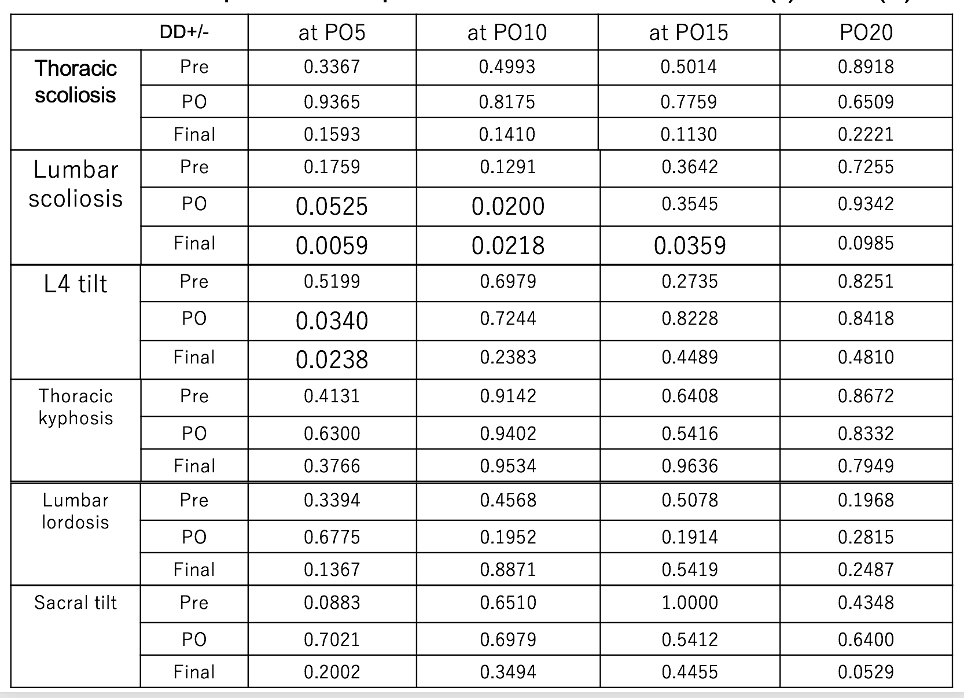

Table 4. Number of Mobile Segments and Occurrence of DD
 |  | DD (-) | DD (+) | p value
Number of mobile segments | PO5 | 4.8 ± 1.0 | 4.3 ± 1.0 | 0.2920
 | PO10 | 5.0 ± 0.9 | 4.2 ± 1.1 | 0.0468
 | PO15 | 5.3 ± 0.7 | 4.3 ± 1.1 | 0.0315
 | PO20 | 5.3 ± 0.8 | 4.4 ± 1.1 | 0.0436

Figure 1. Lenke Type (Lumbar Modifier) & LIV
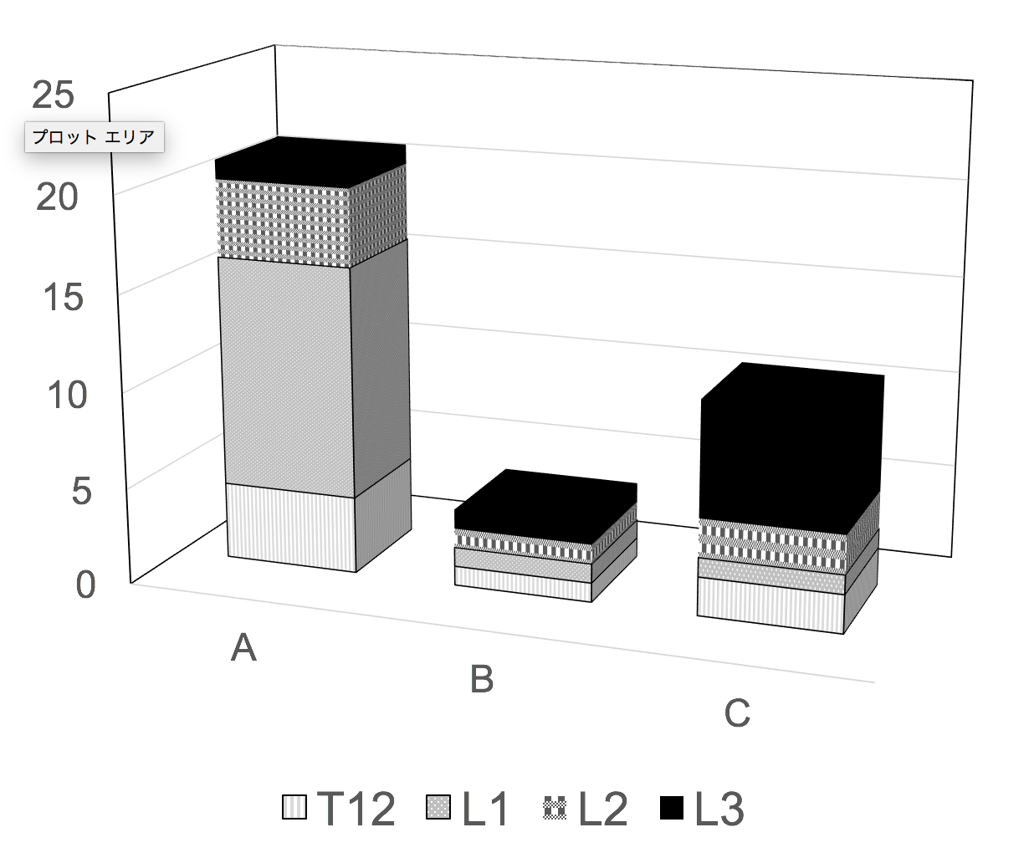

Figure 2. DD in terms of FU Period
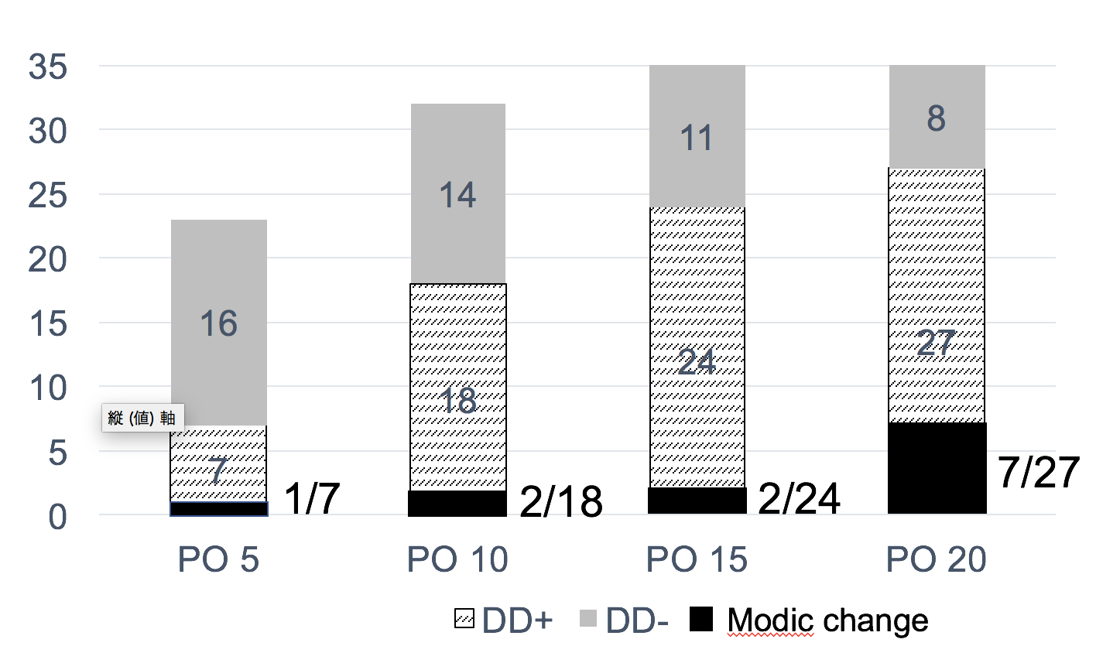

Figure 3. DD in Each Segments

Figure 4. Comparison of DD in Surgical Group with Control Group
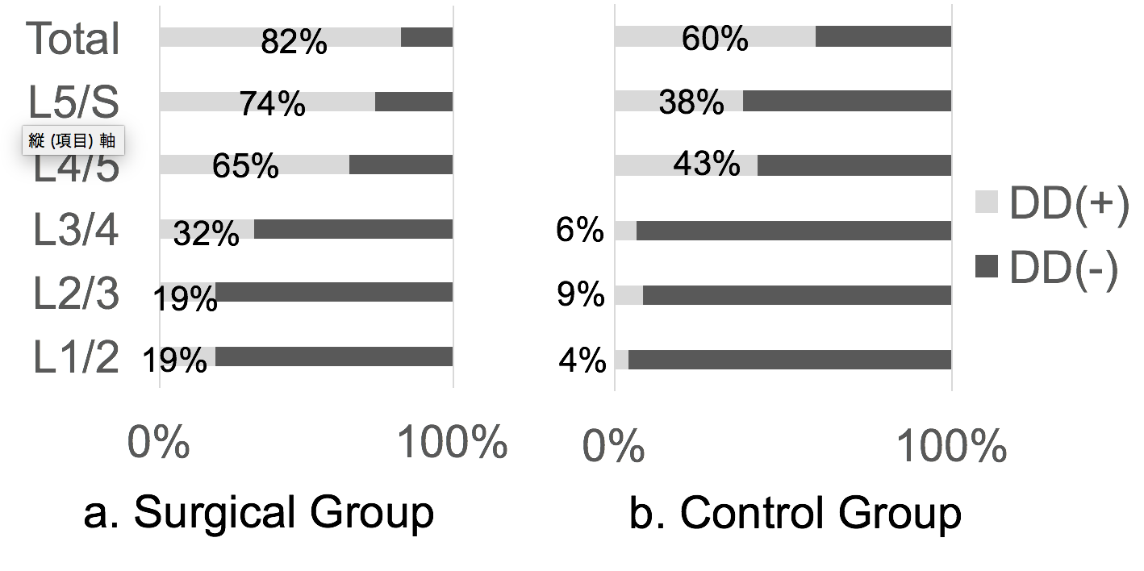

Figure 5. Percentage of DD in Terms of LIV
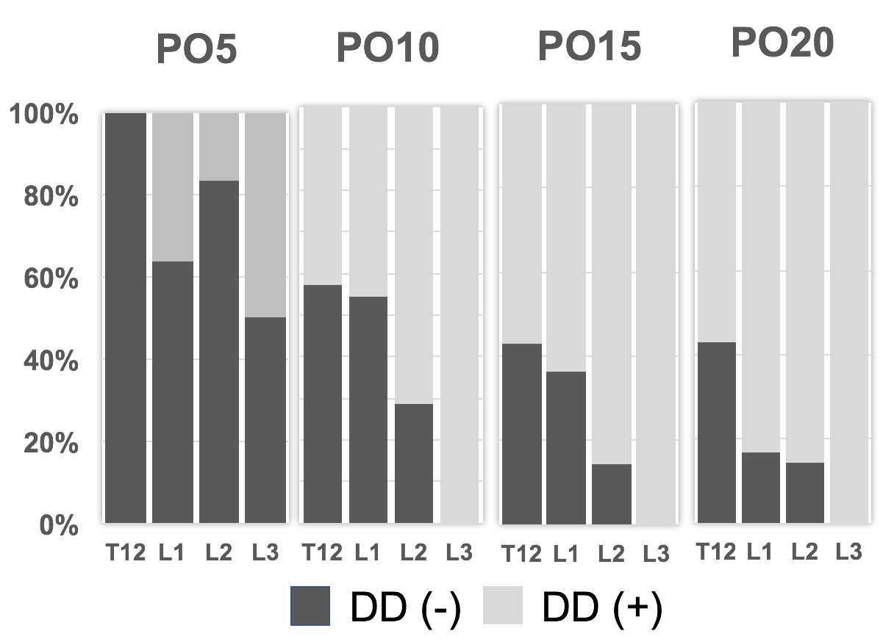

Figure 6. SRS30 Score at PO 10 & PO 20
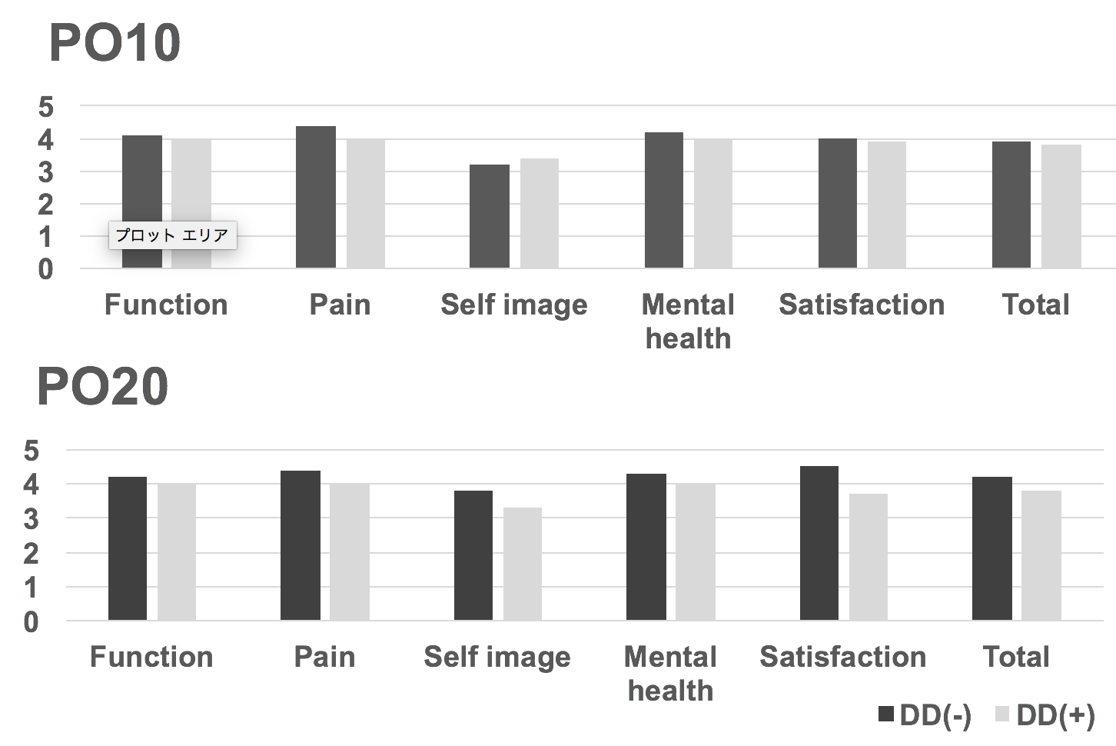

Figure 7. SRS 30 Score & Marital Status At PO20
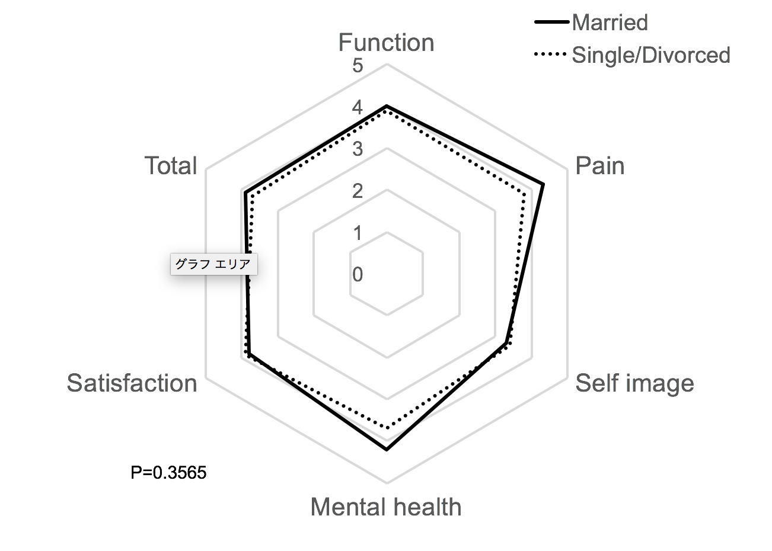

Figure 8. DD in Patients with LBP at PO20
